A PLACE OF MYSTERIES
MARULAN RAILWAY STATION

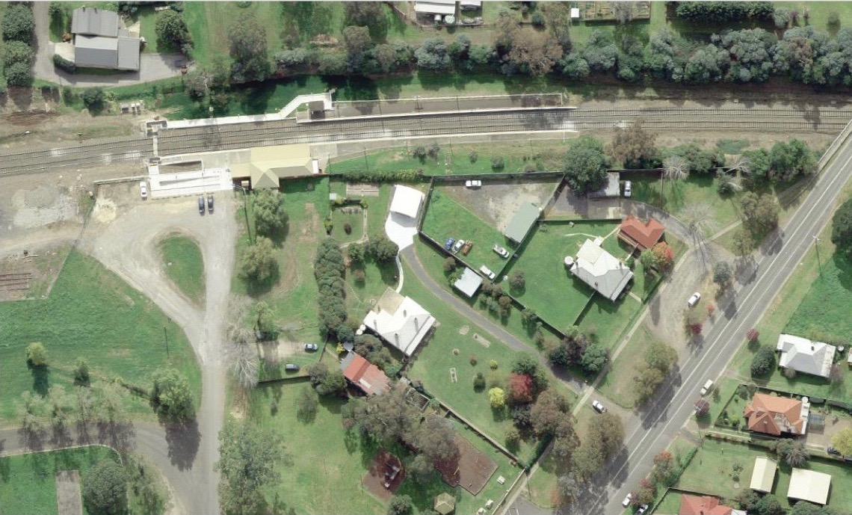

This photograph shows the two platforms, with the white path being the new ramps to each platform to provide disable access. The original building dating from 1868 is the one located at the end of the road access. The house in the centre of the image with four chimneys is the Night Officer’s residence while the Station Master’s house faces the former Hume Highway and also has a white roof. The vacant oblong area between the Night Officer’s residence in the 1868 building is the location of the former Railway tennis court.

Janet and Dugald Black and Stuart Sharp
12th February 2019
THE IMPACT OF THE ARRIVAL OF THE RAILWAY
The big picture is that Marulan is one of those towns in New South Wales that was created by and developed around the railway station.
Marulan did not open to serve an existing urban area. Road junctions were very important places and this was the case at Marulan where the pre-railway site of the village of Marulan was fixed on 10th March 1835 at the junction of “the Great Roads” – with one road leading to Goulburn and the other to Bungonia. The station was erected where it is because it was the easiest transhipment site between road and rail for goods destined for more southern destinations. This transhipment role is reflected in 2018 by the physical direction of the public road leading to the former Hume Highway from the station – in a southerly direction.
Marulan was one of a few locations where the Great Southern Railway line physically crossed the Great Southern Road. Thomas Mitchell’s route for this road went from Mittagong to Berrima, thence to Marulan via Paddy’s River. The original Argyle Road passed to the east of Bowral and Mittagong and crossed the railway route in Moss Vale before heading towards Sutton Forest and then around the western side of Exeter and Bundanoon. Much of this road is still in use today. Crossings of the Railway and the Road also occurred at Picton and Mittagong and the Road came close to the Great Southern Railway between Bargo and Mittagong.
Local historian, Maureen Eddy, argues that the original village of Marulan, which was a couple of miles away, relocated to the station site for economic reasons. The post office operated at the railway station from 1869 to 1878 under the new village name – Mooroowoolen – while the station was called Marulan. Why? Well, the post office at the original Marulan operated under the name Marulan. The site of present-day Marulan was originally a private township which had been laid out and marketed under the name Mooroowoolen (e.g. Sydney Morning Herald, 4th December 1867). The Post Office authorities adopted this name for the post office, which opened initially in the premises of the Terminus Hotel on 1st March 1868 at the suggestion of Mr Philip Dignam, M.P. The post office at new Marulan changed to Marulan in 1878. Perhaps the station name was chosen because at the time (old) Marulan was the nearest settlement to the station site? By 1895, the original village site was “in a state of ruin”.
How big was Marulan? Small is the answer. In 1874, there were reported to be only four houses which were all occupied by people engaged in the provision of public services, namely the Post Master, the Police Constable, the school teacher and the mail contractor. The 1867 postal directory contains 114 entries. The question to be asked is to which Marulan - new or old – does the postal directory refer. The four houses in 1874 seems to refer to new Marulan and does not include the hotel. After all, where did the publican and staff live? Neither did it include the residence at the station. Another omission relates to the school. There was a school at new Marulan from 1870 because most children were living there. Where did the children live? The 114 entries in 1867 included residents of (original) Marulan and some individuals on properties and other locations in the district. The list does not include the names of all adults residing in the area. For example, addresses for individuals in the list include “Glenrock”, “Lockyersleigh” and “Caoura”, but it is known there were many more adults on these properties, or living nearby, than the numbers in the list suggest. For instance, there were 20 or more people at “Caoura” and nearby, plus children, whereas the list suggests there were only two. Many people were illiterate and would not have received any mail.
Churches were established in the village of Mooroowoolen in 1873 and 1878. The Presbyterian (Uniting) Church opened in 1873; the Anglican Church opened in 1878 and the Roman Catholic Church in about 1930, replacing the church at old Marulan built in 1859. The Terminus Hotel pre-existed the arrival of the railway and the Royal Hotel was established in 1880. Photographic evidence from about 1880 shows a few scattered houses as well as the churches. A Masonic Lodge started in 1878. One its keenest members, being to the craft for 40 years, was Mr A. Moodie, the Station Master from 1878 until he retired in 1889.
A school established in 1860 was at old Marulan. A second school was established at Mooroowoolen in 1870, but the school at old Marulan lingered on until 1877. The name of the school at Mooroowoolen changed to Marulan in 1880. The school at Mooroowoolen was at first in rented premises, then in its own building which was occupied in December 1871. A new building was erected in 1884 which is thought to be the present stone building, although it is dated 1887.
Before the village was established around the station, there was a substantial railway camp, which included a shop, bakery and an “accommodation house”.

THE PATTERN OF STATION BUILDINGS – PICTON-GOULBURN – 1863-1869
John Whitton, the Engineer-in-Chief for Railway Construction, provided a suite of three levels of station accommodation for his railway between Liverpool and Goulburn. At the lowest level, was a one room waiting shed with a single-pitched roof sloping to the rear. The original buildings at Buxton, Hill Top, Braemar, Bundanoon, Barber’s Creek (present Tallong) and Carrick featured that simple shed format. The middle level comprised the combination of a residence and official offices, as at Marulan, Menangle and Bowral. The top level was a Georgian design which he used at Campbelltown, Picton, Mittagong and Moss Vale. For the Goulburn terminus, a super-upgraded version of the Georgian standard was utilised. While the floor plan and overall symmetry was much the same, the decoration was based on the Italianate style. The change of design used at Goulburn is probably explained by the fact that Whitton was on leave overseas and it was his second in charge, William Mason, who approved the application of the Italianate design – the first such usage on the rail system.
THE DESIGN FAMILY TO WHICH THE 1868 MARULAN BUILDING BELONGS
The idea of combining in one structure offices and other rooms for railway business with a house for the Station Master and his family came from the United Kingdom. Combination structures were first used in 1855 between Sydney and Parramatta at Newtown and Ashfield, though the design was different to that at Marulan. A range of different designs continued to be implemented up to 1858, after which John Whitton introduced a standard design that he continued to use up to 1869. Between then and 1876, he used another combination design, some of which were of two storeys. With one exception, it was 1876 which witnessed the last combination structure.
Beyond Campbelltown, Whitton used a square-shaped building for some gatehouses, similar to the Marulan station building but void of the railway offices. The only example of this style survives in 2018 at Burradoo but he used the same basic design, with some variations, for the Pumper’s house at Couridjah, which is also extant. He then used the same square-shaped building as the basis for the stations at Marulan, Menangle and Bowral, and added spaces to the front containing a ticket office, an opened-fronted but covered public waiting area, a ladies’ waiting room and a semi-detached toilet block.
The notion of building a single structure containing both a house and official offices was aimed at saving money. There were no free-standing residences for Station Masters at the time the various sections of line to Goulburn were opened between 1863 and 1869. However, there was one exception and there always seems to be one exception in the history of the New South Wales Railways. A few months after the opening of the line to Moss Vale, a Gothic styled brick house was built near the station in 1869, which stands today though in a very modified form. The next freestanding residences for station staff was at Goulburn in 1870 and at Mittagong in 1874 and, from 1874, free-standing residences were added to both new and existing lines.
THE BUILDING ON THE GOULBURN-BOUND PLATFORM
William Mason, the Acting Engineer in Chief, approved the plans for the building at Marulan on 3rd December 1867. The design of the structure was one that his boss, John Whitton, had introduced in 1857 and utilised at the time for stations where staff were to be appointed but there was no or little urban development to be served by the proposed station. The building was basically a square house with rooms for railway functions built facing the platform. The residential accommodation comprised two small bedrooms, a parlour and an internal kitchen.
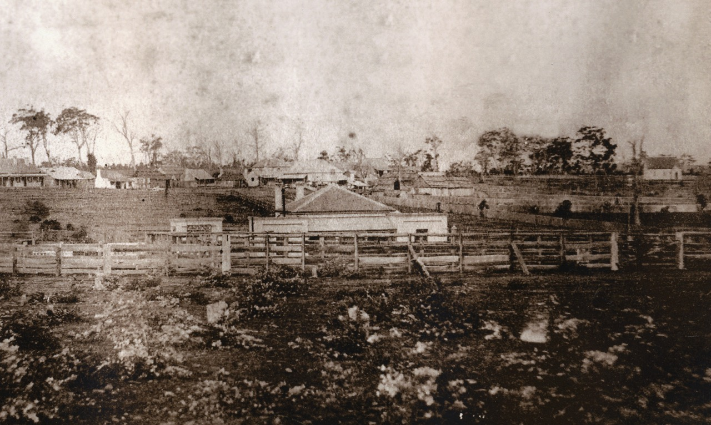
Marulan railway station (circa 1880) – from a photo montage of the village taken from vicinity of Station St looking south east. (Marulan and District Historical Society collection)

Facing the platform was a ticket office and a ladies’ waiting room at opposite sides of the residential component and a semi-detached toilet block. Between the ticket office and the ladies’ waiting room was an in-antis awning 24 feet long and 12 feet wide covering the platform. There was to be a semi-separate toilet block eight feet from the ladies’ waiting room. The semi-detached toilet block as well as the matching ticket office possessed parapeted roofs. The toilet block contained separate facilities for men and women which discharged directly into cess pits below. The only connection between the toilet block and the main building was a narrow passageway that connected the ladies’ waiting room and the female closet. In so doing, the ladies’ waiting room acted as an ante-chamber to the women’s toilet to provide a high level of personal protection from lingering males. This accorded to general Railway policy but, many men unfamiliar with the ways of women, wondered whether ladies ever had the need to use closet accommodation.
There was no separate toilet for the Station Master and his family (in the case of Mr Moodie, he had a wife and six children). Luckily, they did not have to walk onto the platform to use the facility. Doubtless, they would have had one or more commodes in the residence for use at night, especially, as everyone else did. There was a rear gate in the galvanised iron fence which connected the ladies’ waiting room and the toilet block.
All the doors in the structure were of the same width, namely two feet nine inches wide. Interestingly, this width became the future standard not for doors but for windows. In the Marulan structure, the windows were three feet three inches wide. The staff sold tickets to the travelling public through a tiny ticket window which faced into the covered area under the platform awning.
The railway offices at Marulan, but not of the residence, were built opposite to the plan – an occurrence that happened a few times with the New South Wales Railways in the 19th century. Nevertheless, why reverse the plan at Marulan? A couple of possible reasons are worthy of contemplation.
Firstly, the station entrance and the dock platform were at the Goulburn end of the building and it would probably be considered undesirable to have the toilet block, and especially the ladies’ waiting room, next to these. Reversing the plan would also have the advantage of putting the ticket office close to the entrance. The horse dock was retained in its planned position.
Putting the entrance at the Sydney end would have meant it was cramped due to the proximity of the embankment at the rear of the platform and more difficult for passengers from horse drawn coaches and wagons to access. Chalk up a mystery.
On the very day Mason had approved the plans for the station, the advertisement calling for tenders for its construction appeared in the Government Gazette. That was indeed very rare and there is no doubt an unexplained mystery why that occurred. Tenders for the construction of the station building and platform and the goods shed closed on 24th December 1867. Fred Horn, a well-known builder from Goulburn, F. Williams and Joseph James were awarded the contract for the construction of the platform and station building at Marulan. They signed the plan on 20th February 1868. Horn was a leading citizen and one-time Mayor of Goulburn. He also constructed the station buildings at Mittagong, Goulburn, Gunning, Yass Junction, Tarago, and Tarana as well as the second Sydney station building in 1874.
The design features of the Marulan building were:
- Unembellished, simple Georgian design influence,
- Main structure symmetrically set out with symmetrically-placed chimneys, pavilions and awning posts,
- Brick construction set in English bond,
- Hipped roof covered with Welsh slate,
- In-antis awning with exquisitely turned, timber vertical support posts,
- Undecorated horizontal window heads with sandstone lintels,
- Undecorated sandstone window sills, horizontally set, &
- Brick chimneys with decorative corbelling,
Marulan became the terminus of the railway when it opened on 6th August 1868 and remained the terminus until the extension to Goulburn was opened on 27th May 1869. There was no description the station building in the press reports of the official opening.
THE GOULBURN-BOUND PLATFORM
Whitton approved the provision of a stockyard in 1871, but the idea was flawed from a passenger perspective. Tenders for the stockyard construction closed on 22nd August 1871.
The unbelievable feature was the placement of the stockyard and stock-race directly opposite the passenger platform. Why would he do that? The odours and noise created a very unpleasant situation for people waiting on the platform. The opposite was also a problem. People on the platform upset the livestock and made them agitated and hard to handle. Marulan was not the only instance of such a silly arrangement, with other examples being at Maitland and Glen Innes. Adjacent to the stockyards was a wool loading platform. The stockyards continued to irritate local travellers until 1913, at which time the Department decided to relocate them to make way for a refuge loop for Sydney-bound trains.
The passenger platform in 1868 was planned to be 235 feet long by seven feet wide, being of constant width, unlike Whitton’s policy of usually widening the platform in front of the station building. He probably thought that the area covered by the in-antis awning achieved the same purpose. The relatively narrow width of the platform was consistent with the time but the policy changed in 1870 with the introduction of a standard width of 12 feet.
The gravel surface of the platform was to be the then standard of two feet nine inches above the head of the rail, though subsequent press reports stated the height at two feet three inches and at three feet. Which was correct? Who knows – another mystery! The only platform seats were two long benches affixed to the walls of the building, meaning that there were no backs to the seats – primitive indeed! The brick platform wall sloped to the toe, which was standard policy at the time. The platform face acted as a retaining wall for the earth-filled platform. At each end of the platform, “inclines”, meaning ramps, 15 feet long were provided. Attractive, cross-braced timber fencing was erected at the rear of the platform. The fencing style was the same as provided at Goulburn in 1869 and was a classy feature and added to the attractive near-symmetry of the Georgian-influenced building. There was a dock at the Goulburn end. In 1883, the platform was approved to be widened – to what extent is unknown.
The widening was achieved by demolishing the ticket office, ladies’ waiting room and toilet pavilions, moving the first two inside the former Station Master’s residence, as the Station Master had a new separate house in which to live. There is no obvious indication of the track having been re-aligned to accommodate a wider platform.
The original 1868 platform survives, providing the evidence that the platform widening had been achieved by cutting back buildings, i.e. by removing the three pavilions rather than re-aligning the track. The original platform is located in front of the existing station building. A very long extension was made at the Sydney end at an unknown date. However, the change in style of platform wall construction gives a clue. Whereas the platform face approved by Whitton is in a constant plane, that part at the northern end is not. The northern extension has a vertical wall, compared with Whitton’s sloping wall, and features extended courses of brickwork immediately below the coping (i.e. at the top on the platform surface). The variable width of the brick courses under the coping suggests a post-1900 extension of the platform and was possibly extended at the same time as duplication.
Even in 1978, there were two steps down from the platform level into the brick building. Here is another puzzle. There are currently two steps down into the building following the platform raising in the 1990s. How come? There is no learned reply at this time. At that time, both platforms were 488 feet (149 metres) long. In an act of heritage destruction, CityRail raised the platform level to its present height in the 1990s but, in the process, buried the decorative bases of the vertical platform awning posts.
Today, the distance from the platform face in front of the building to the verandah posts is six feet (1.9 metres). From the verandah posts to the wall is just under 12 feet (3.6 metres). The total platform width is, therefore 18 feet (5.5 metres).

THE MAJOR CONVERSION OF THE 1868 BUILDING – GOULBURN-BOUND PLATFORM
Unfortunately, no plan exists to date and detail the conversion of the 1868 combination structure into one that was used solely for railway purposes. A number of other ways of determining the date of the change is available and these are examined separately. Firstly, what were the physical changes?
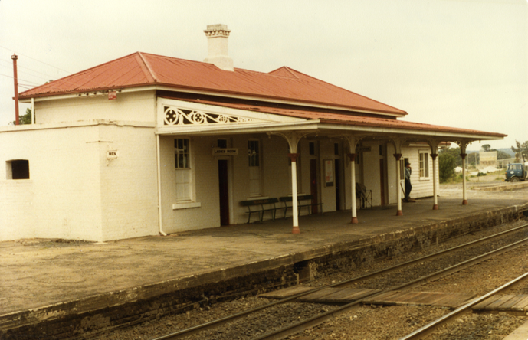
The above photograph shows the male toilet at the Sydney end and the parcels scales towards the signal box. Two platform seats are located under the awning, which were built to a design introduced after World War Two. This photograph and that below were taken on 2nd December 1983 and are from the G. Dorman collection in the ARHS Resource Centre.
The photograph below shows the timber signal box, which dates from the period 1913-15, and the 1868 building looking in the up direction. The original platform wall is in position in front of the station building but it will be noticed that a different style of platform wall was used for the extension at the Sydney end. Also worthy of notation is the original, remnant roofing slates on the hip of the roof facing towards Goulburn.
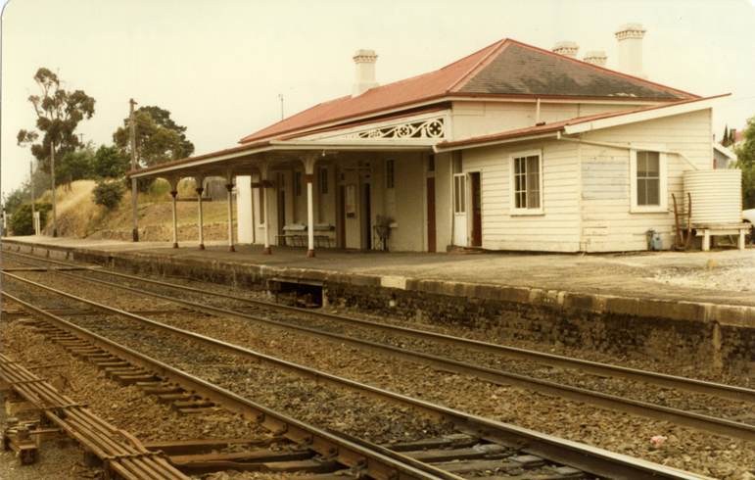

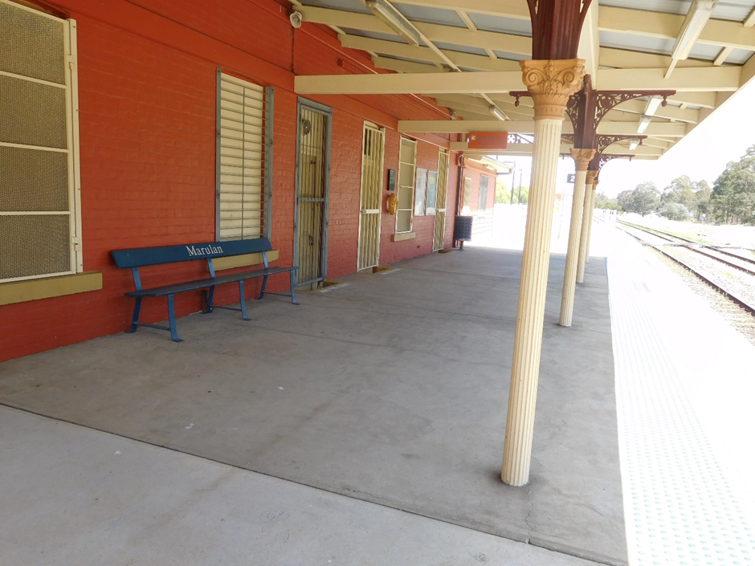
This image shows the new, raised platform and contrasts with the previous two images taken prior to the raising of the Goulburn-bound platform. The fluted, vertical awning posts with ornate capitals and ornate brackets are visible. Only one platform seat remains after the other the second seat was stolen in October 2018.
A - THE NATURE OF THE PRE-1886 ALTERATIONS TO THE 1868 BUILDING
The alterations undertaken in the 1880s to the building on the Goulburn-bound platform were substantial, resulting in the 1868 building being unrecognisable, except for the remaining slate roof covering and the chimneys. The overall footprint turned from being a square with three pavilions on the rail elevation to an “L” shape, plus a rear protrusion and one detached pavilion (the male toilet) at the Sydney end. The Station Master’s residence was no longer in the platform building.
The decorative features of the much-expanded platform building included:
- beaded heads to doors,
- slightly arched window heads,
- fluted iron columns with ornate capitals and brackets supporting the platform awning,
- ornamental spandrels at the ends of the platform awning, &
- dentil course of bricks on external walls under the eaves.

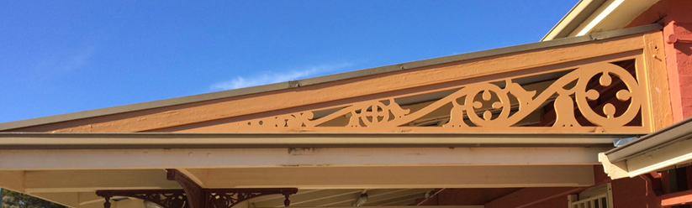
This illustration shows the spandrels that were applied to each end of the platform awning. Photograph taken 3rd July 2018.

B - THE GROWTH OF THE URBAN AREA SERVED BY THE STATION
The key question to ask is the extent to which the growth of the village contributed to the decision by the Railway Department to convert the 1868 combination building into a structure containing only operational spaces. In the 10 years from the opening of the station, the village did grow, but was that population growth the stimulus for the very substantial and extensive alterations to the platform building? While the senior railway offices would have known of the increase in local travel demand through the growth of the urban area, this population increase would not have been sufficient to account solely for the large expenditure involved to build a separate residence for the Station Master in 1882. Other factors were at play.
C –DOCUMENTARY EVIDENCE
The Annual Report of the Railway Commissioner states that a verandah was added in 1874. That reference might initially suggest that it was at that time that the platform was widened, and the present posted awning provided. This does not seem to have been the case as the Annual Report later states that the platform was widened in 1883. Another significant item of evidence relates to the fluted cast iron awning columns. That material was not used in the 1870s and was used sparingly even in the 1880s.
There is another tricky piece of evidence. Two track plans exist which are dated 1888 and show the outline of the platform buildings as they were in 1868. Probably, the draughtsman was focusing on other issues in the preparation of the plans. For example, although the plans were dated 1888, they did not show the division of the stockyards between 1882 and 1885. These plans can be dismissed as sources of accurate information about the design of the platform buildings in 1888.
By 1882, the Railway Department had completed plans for a new, detached brick residence for the Station Master. Work was “in hand” by the end of 1882. Next, tenders closed on 3rd April 1883 for the supply of 30,000 bricks to Marulan station. Was that supply of bricks intended for the building alterations? No - perhaps. They were to be used, it may seem, for the construction of the Station Master’s house, but surely that did not account for so many bricks? The tender documentation also included supply of large quantities of bricks to many other places on the Main South line. What was going on is a mystery.
Official timetables reveal that there was very little increase in the number of passenger trains from 1868 to 1900 stopping at Marulan. There was, basically, a day train and a night train, the latter becoming the mail train eventually. In 1883, the official timetable indicates that the “stations”, meaning the location at which staff were employed, between Moss Vale and Goulburn were Bundanoon, Cable’s Siding (now Penrose), Wingello, Barbers Creek (now Tallong), Marulan, Carrick, Towrang, North Goulburn and Goulburn. All other stopping places were unattended “platforms”.
D – EXAMINATION OF THE BUILDING FABRIC
One indicator of the possible date of the alterations to the building at Marulan is the provision of the fluted, cast iron vertical posts supporting the platform awning. Posted awnings were very popular in the 19th century but, contrary to what might be expected, there were only 12 instances, including Marulan, where the iron platform columns were fluted. All these occurred between 1880 and 1885. The other 11 examples were:
- Albury 1880
- Eskbank 1880
- Hay 1881
- Granville 1881
- Emu Plains 1882
- Blacktown 1883
- Windsor 1883
- Jerilderie 1884
- Petersham 1884
- Stanmore 1885
- Parramatta 1885

All but two occurred on existing lines with those at Albury, Hay and Jerilderie being the only stations to have fluted columns on new lines. All occurred between 1880 and 1885. The pattern of the use of fluted columns suggests that those that Marulan were approved in the first half of the 1880s. The present building on the Goulburn-bound platform at Bowral was erected in 1889. It was a fair-sized and good-looking structure but even it did not feature the fluted iron columns and ornate cast brackets that were provided at Marulan. Perhaps the Marulan project was given these niceties, given that the overall building looked crappy, to draw attention away from the unattractiveness of the structure following the alterations?
Another decorative feature that was rarely used was the spandrels at the ends of the awning over the platform. As far as is known, only four other stations featured spandrels, and these were all on new railway lines. The four were:
- Sandgate Cemetery 1881
- Armidale 1882
- Molong 1885
- Helensburgh 1890
The building at Marulan was the only instance in the history of the rail system with spandrels that were provided to an existing railway station. Thus, the use of fluted awning columns and spandrels at Marulan indicate a significant effort by the railway bureaucrats to enhance the appearance of an otherwise pedestrian structure following its enlargement.

E - PHOTOGRAPHIC EVIDENCE
A photograph of the station is in the collection of the Marulan and District Historical Society. It is an important item of evidence. The photograph was taken between 1878 and 1880 and shows that the suite of structures that existed in 1880 was exactly those that had been erected in 1868. There had been no additions. So, in 1880, nothing had changed at the station.
Cyril Singleton wrote an article in 1969 relating to the centenary of the opening of the line to Goulburn. In it, he included a photograph allegedly of Marulan taken in the late 1870s. The photograph is not of Marulan as the three pavilions facing the platform are in the incorrect order for that station. It is possible that image was taken at Bowral.

F - PRESS REPORTS
There is some evidence in the local press that provides an indication of the changes to the Marulan railway facilities. A press report in the Goulburn Herald and Chronicle, on 2nd November 1878 gave a few snippets of information about the station at that time. These were:
- the Great Southern Road crossed the Great Southern Railway by a level crossing,
- the level crossing gates were shut at 1800 each night, thus requiring riders to leave their horses at that location and walk to the station, &
- the post and telegraph offices formed part of the block of buildings at the station.
The next piece of information about what was going on at the Marulan railway station involved a press report about the visit by John Gannon, who was one the Members of Parliament for the electorate of Argyle, which included Marulan and Goulburn. The Argyle electorate returned one Parliamentary member from 1856 to 1880 and then two members between 1880 and 1894. One Member who served for the entire period was William Holborow. The second Member changed six times, but it was John Gannon who represented the electorate between 1880 and 1885. Interestingly, Gannon was followed by Henry Parkes for a short time in 1885.
The Marulan Progress Committee invited Gannon to visit the town, which he did on the 24th January 1882. A local deputation met him at the station and walked around town pointing out the various needs for improvement. The first railway item was the then recently-constructed, timber road overbridge across the railway line on the northern approach to the town. The deputation pointed out that:
“the railings of the bridge being some two feet apart. It has been felt necessary that some better provision should be made to prevent children from falling through”. The Progress Committee then “pointed out to him the paucity of platform accommodation, also the miserableness of the waiting room.
Another undesirable feature noted at the passenger station was the cattle and sheep trucking yards exactly opposite thereto. Not only is it anything but a pleasant feature to passengers, but stockowners are continually finding fault with the insufficiency of the drafting yards, and also complaining of the difficulty in loading livestock when any person is on the platform”.
….this station has the worst accommodation and is one of the best paying ones for the small staff required to work it”.
At that time, approximately 13 passengers a day departed from the station, based on figures for December 1881.
Another report of the same inspection revealed more information about the state of Marulan railway station. The deputation:
“pointed out the narrowness of the platform and shortness of the same, besides the level which was stated to be fully a foot below the level of floor of a railway carriage, the height from the rails of the permanent way to the surface being only two feet three inches. The closet accommodation was very bad, as was the ladies' waiting room, which had no provision for a fireplace. While at this place, we asked permission to inspect the station master's quarters, which we found to be very small and crowded, and noticing a number of intelligent looking children (in total six children) we failed to comprehend how they contrived to live in such a close atmosphere, caused by small and badly ventilated rooms. On asking Mr. Moodie how he contrived to exist in such a small house, he said ‘government officials can exist anywhere.’ He seemed very reticent in giving Mr. Gannon or anyone information”.
The deputation also inspected the post office which was described as a “box”. Gannon promised “to do his utmost to get the necessary improvements at the station and “goods” sheds effected”. Surprisingly, three months later, Gannon was successful in providing greater protection on the road bridge with the installation of galvanised iron sheeting used for the balustrades. The installation of the corrugated iron sheeting on the bridge is not of great interest in itself, but it does indicate that John Gannon was able to influence the Railway Commissioner to carry out improvements to Marulan station pretty quickly.
A possible key event was the inspection of southern line stations in March 1884 by senior staff. It was the statutory requirement of the Commissioner to inspect every station annually. With him was George Cowdery, the Engineer for Existing Lines, who was the officer responsible for approving all works at Marulan station. The press reported:
“Marulan station was next visited; ample accommodation is afforded here, as the station-master has recently removed into a new building. A small matter was brought under attention, which is worthy of mention. Generally, when a telegraph operator or probationer is sent to a country station, he has to take lodgings at an hotel. Young and impressionable, he is easily led into loose habits, and the ruin of a promising lad is sometimes the result. Noticing that there was a spare room at the station, the Commissioner wished to know whether the telegraph operator could not make use of it, and thereby avoid the temptation created by going to an hotel. The inquiry was a thoughtful and a kind one, and the general adoption of the principle would lead to very beneficial results”.

There is some description of the station in June 1885 during a Coroner’s inquest into the death of a man who had fallen from the platform on to the track to his death. The key pieces of information were:
- The vertical distance from the platform to the track was two feet three inches,
- There was a light in the “operating room” and the one light in the centre of the platform was not lit,
- There was a lamp over the entrance, but it was also not lit on the night and, in fact, never lit,
- The Night Officer’s orders were to light the platform lamp only one half hour prior to the arrival of the mail train and at no other times,
- The entrance to the platform was described as “dangerous” without a light, &
- After the entry, there was a sharp turn to the right to prevent falling off the platform.
One 21st century railway commentator, Jim Craddock, wrote that “country stations were not famous for their bright lighting, even after the installation of electric lighting.”. How true this was in the case of Marulan station! It is little wonder that the Coroner recommended the station light be lit at all times during the night.
There is one very pertinent item that gives a clue about the building alterations. A correspondent wrote on 19th August 1886 that “the buildings at the railway station are not completed yet; but patience is a virtue, and I suppose we must wait”. The correspondent also mentioned the current position about the 1885-approved post office, the plan for which was prepared by the Railway Department. He added:
“Some time ago, plans were drawn for a court house to be built here, but I have not heard anything about it lately. I suppose it will be the same as our Post and Telegraph Office - a long time getting built, and then eight or nine months standing empty. The new Post Office was opened this week”.
The expanded facilities had not been completed in April 1886, the station building being described then as “rather small”.
G - COMPARATIVE ANALYSIS
To understand the timing of developments at Marulan station, information has been collated on building additions and improvements to all stations between Picton (inclusive) to Goulburn (exclusive). This information is set out in station order in Appendix 1. What does an analysis of the table reveal in Appendix 1? It shows a significant number of additional stations opened between 1878 and 1888. The 11 stations were:
- 1878 Balmoral, Hill Top, Exeter and Barber’s Creek (now Tallong)
- 1882 Wingello and North Goulburn
- 1883 Colo Vale and Werai
- 1885 Thirlmere and Kareela
- 1888 Murray’s Flats
With 10 of the 11 stations dating between 1878 and 1885, it is fair to say that the eight years between 1878 and 1885 was the busy time in regard to the development of passenger business. These 11 stations were added in a 10-year period to the original eight stations (Couridjah, Braemar, Mittagong, Bowral, Moss Vale, Bundanoon, Marulan and Carrick).
Appendix 1 also provides information about the various times in which improvements were made at each station. The list below analyses the timing of developments at each station by year, with special reference to Marulan.
1873 Mittagong (refreshment room)
1874 Marulan (verandah added)
1876 Marulan (new kitchen installed in residence)
1878 Platform at Barbers Creek (now Tallong)
1879 Marulan (entrance gate removed) and Burradoo
1880 Marulan (windows fixed in residence) and Mannafields
1881 Picton, Balmoral, Braemar, Mittagong, Moss Vale, Bundanoon and Mannafields
1882 Marulan (new residence ‘in hand’) and Picton, Mittagong, Bowral and North Goulburn
1883 Marulan (platform either authorised to be widened or widened) and Couridjah, Colo Vale, Mittagong, Bundanoon, Wingello and Mannafields
1884 Picton and Colo Vale
1885 Marulan (post office relocated) and Hill Top
1886 Mittagong
1887 Mittagong
1888 Nil
1889 Moss Vale and Bowral
1890 Moss Vale (refreshment room) and Couridjah
So, what is the pattern with the above chronological information? It shows that the dominant time for construction was between 1880 and 1884, when 22 projects were undertaken in the section between Picton and North Goulburn. That contrasts with eight projects taken in the five years between 1885 and 1890. George Cowdery approved and rebuilt moderate or large buildings at Bundanoon in 1881, Wingello in 1882, Thirlmere in 1885 and Bowral in 1889. Clearly, there was sufficient money for such a large works programme during the 1880s decade.
I - STAFF LEVELS AND OPERATIONAL STATISTICS
So far, the best guess of the date for the approval to re-arrange the Marulan building is 1883 or shortly thereafter. It might be 1884 or 1885 when the approval was given but the date is a big mystery. It is possible that the building alterations were necessary to achieve platform widening. Although comprehensive staffing levels and other station statistics are not available, there is some information which indicates that 1883 was the peak year for both staff numbers and ticket sales. The Table below sets out the statistics.
MARULAN STATION: STAFFING LEVEL AND TICKET SALES
YEAR | NO. OF STAFF | NO. OF TICKETS SOLD
1869 | 2 | -
1871 | 4 | -
1878 | 2 (only the salaried staff) | -
1882 | 6 | 4,447
1883 | 8 | 7,233
1885 | 5 | 5,157
1889 | 5 | 3,077
1890 | 4 | 2,724
SOURCE: Commissioner for Railways, Annual Reports and J and D Black, Moss Vale to Marulan: 150th Anniversary of Opening of Railway….Marulan and Medway Junction, Marulan and District Historical Society, 2018, pp. 17-19.
Passenger business was brisk, for a small station, in 1882 with 380 passengers departing the station in March of that year. Outwards tonnage for the same month was 763 while inward tonnage was 815. The telegraph office at the station transmitted 144 messages or about five a day.
In April 1884, the number of passengers leaving the station was 385; outwards goods were 878 tons and inwards goods 190 tons. For May 1884, outwards passengers were 358; inwards tonnage 216 and outwards tonnage 486. For July 1884, the number of outwards passengers was 414; inwards tonnage was 157 and outwards tonnage was 459.
Statistics are given for October 1885 when 397 passengers departed. Inwards tonnage was 193 and outward 755. In January 1886, there were 390 outward passengers while inwards tonnage was 236 and outward was 606.

J - A SUMMARY OF THE EVIDENCE WHICH MAY EXPAIN THE TIMING OF THE CONVERSION AND ENLARGEMENT OF THE 1868 BUILDING
In summary, the following information suggests that the existing building was altered from the combination structure in 1886 or thereabouts, following an approval around 1883, 1884 or 1885. The key findings are:
- the urban area served by the station grew substantially during the 1870s and, in 1880, provided a much higher level of passenger travel demand than 1868,
- the photographic evidence taken between 1878 and 1880 confirms that the 1868 structure was intact in 1880,
- The press reports in 1882 relating to the inspection by John Gannon, M. P., Indicates that he was successful in making contact with the Railway Department and of achieving some results,
- the start of construction in 1882 of the detached Station Master’s residence indicates the start of the planning process to reconfigure and rebuild the platform structure,
- The inspections by the Minister for Public Works, the Engineer-in-Chief and the Commissioner in March 1884 provided the opportunity to inspect the building with the vacant internal spaces,
- the time period in which fluted awning posts and spandrels were utilised elsewhere on the rail system suggests that the approval for the application of these decorations occurred prior to and including 1885,
- the increase generally in travel demand between 1878 and 1885 along the Main South rail corridor, as reflected by the opening of 11 new stations in the period, heightened the attention of the Department to the community pressure for improved station facilities,
- the high degree of construction work at virtually every station between Picton and Goulburn between 1880 and 1885 indicates the existence of a broad Departmental policy to meet local community demands – when funds were available,
- the press reports of July and October 1884 about the relocation of the post office into another room in the platform building demonstrates that officials were planning at that time to alter the 1868 building,
- the approval for the construction of a new post office in September 1884 is suggestive of a similarly-timed approval for station building alterations,
- the Coroner’s inquest in June 1885 confirms no construction work had taken place,
- the curtailment of station renewal work after 1885, due to the tightening financial situation, indicates approval for the building conversion prior to or in 1885,
- the maximum staffing levels in 1883 at Marulan added to the community demands for more waiting room and other space and further suggests approval for the changes in the middle of the 1880s, &
- press reports in 1886 indicate that physical work was under way.
Of course, the dating of the substantial change in building design is only guesswork but it represents the best guesswork in the absence of other evidence.
No matter when the change occurred, the local residents had no complaints. One press article in 1895 stated “the railway station is up to date and everything kept in good order. There is a spacious goods shed. Interlocking signalling apparatus has lately been fitted up”.
POST-1886 ALTERATIONS TO THE 1868 BUILDING ON THE GOULBURN-BOUND PLATFORM
The first improvement at Marulan station after the completion of the 1886 conversion related to toilet improvements. In March 1888, “automatic earth closets” were provided at both Marulan and Goulburn.
At an unknown time, the detached male toilet on the platform was demolished and the main building was extended at the Sydney end to provide a new toilet. A part of the work was the erection of an unusually placed privacy screen set on a diagonal angle that covers the entrance to the male toilet. It is a unique feature across the whole New South Wales rail system. Inside, a simple timber sheet has been placed over the single urinal that had been installed about the 1960s. One closet is in use and there are two other empty closets. The former male toilet is the only internal space open in 2018 to the public, though there is no signage to identify the space as a unisex toilet. One would think that the cover over the urinal is evidence to support the notion that the toilet is unisex. Not necessarily so when the unisex toilet at Tahmoor is considered. In October 2018, Sydney Trains opened an accessible toilet in the 1919 former male toilet block on the Sydney-bound platform at Tahmoor. Guess what? It has a new, open stainless urinal.
The Railway Department paid for the 1885 post office on the main road as a means of getting rid quickly of the postal function from the station, according to local legend.
In 1979, the building measured 68 feet 5 inches long by 15 feet 4 inches wide at the Sydney end. The rooms, from the Sydney end, were:
- male toilet,
- ladies’ waiting room and toilet,
- office,
- general waiting room, &
- ticket office.
The general waiting room was unusually deep, this feature being permitted by the conversion of the former residence into railway operational space. It measured 24 feet 6 inches by 13 feet 5 inches wide. By 1998, some of the rooms had been re arranged. The former ladies’ waiting room at the Sydney end was being used as a general waiting room and it contained two toilets.
An investigation into the colour scheme on the building in 1998 revealed that the initial paint colour was brown. It was then repainted in cream; then repainted in grey and back to cream. Next, by 1982 the structure was painted white, with that part of the roof covered by iron sheets, painted red. In 1983, the building had received no attention in the previous 50 years. The platform level was very low; galvanised Cyclone steel fencing had been erected at the rear of the platform on the Goulburn side of the signal box to replace the then timber, two-rail fence; there was a parcels scales towards the southern end of the building and there were two, yellow-painted platform seats, which remained in position until October 2018 when one of the seats was stolen. The remaining seat is painted in the dark blue colour of the late-CityRail (post 1996) period.
CityRail about 1991 diminished the heritage values of the structure and obliterated an important element of interpretation by the removal of the four chimneys that existed at the rear of the platform building. The desecration did not stop there. It raised the platform level and, in the process, buried the bases of the iron awning columns. Could it get any worse? Yes. It reroofed the structure and, in so doing, removed the remaining 1868 slate from the roof on the southern elevation. Now, we have a green-coloured roof. Luckily, the very large flower garden at the Sydney end of the platform survived removal, but even it was gone by the end of the decade.
Virtually every station in the 1990s in the CityRail network received the white-painted, loop-top steel fencing and Marulan station did not escape the treatment. The galvanised steel fencing was removed. Unfortunately, the new painted fencing was inconsistent with the heritage values of the site. Had a more powerful local community group existed, at least a less intrusive paint colour would have been used, as occurred at other stations which had the support of active, knowledgeable and powerful local pressure groups. Possibly the other horrific features of the station “upgrade” in the 1990s could have been avoided. With the same decade, two red-coloured rubbish bins were provided on the platform, the colour choice being used to display the identity of the owner (i.e. CityRail). The two bins remain on the platform in 2018 but the early-CityRail red colour has been replaced by the dark blue colour of the late-CityRail (post 1996) period.
All the buildings in the railway precinct have been universally and unauthentically painted a terracotta colour in about 2016.
DESCRIPTION OF THE SIGNAL BOX ON GOULBURN-BOUND PLATFORM
The signal box was one of 227 examples built of that style between 1908 and 1922. The most prolific time when the majority of boxes of this type were constructed was between 1912 and 1919. A standard plan was prepared on 17th June 1911 to which the example at Marulan was built. The signal box at Marulan measured 17 feet six inches (5.4 metres) external by 12 feet two inches (3.7 metres) external. While the length of the examples varied according to the subtype and over time, the width was always constant. The length varied between 10 feet and 37 feet and depended on the length of the internal interlocking frame.
There were five variations in addition to the standard type but the structure at Marulan was built to the standard and dominant basic type, which contained 95 examples. The distinguishing architectural features were:
- floor of signal box set flush with platform surface,
- hardwood timber framing,
- external walls clad in six inch wide by one inch thick, lapped hardwood weatherboards horizontally set,
- timber plinth at base of structure ten inches wide,
- single pitched roof sloping towards the platform coping,
- galvanised, corrugated iron sheets covering roof,
- the height at the front of the box was nine feet and 11 feet at the rear,
- doorway on rail elevation in one corner,
- timber framed window with “standard” sliding sashes on rail elevation,
- “standard” box sash window in each end wall (one window omitted at Marulan on wall adjacent to 1868 building),
- basic version with internal walls lined with four inch wide by half inch thick, tongue and groove horizontally set boards,
- timber lining boards used for horizontal ceiling,
- hardwood flooring four inches wide by one inch thick,
- stove in front corner opposite the door, vented by steel flue through ceiling,
- mechanical interlocking machine parallel to rear wall, &
- painted externally in medium stone with dark stone trim.
At an unknown time, a screen door was fitted to the existing door leading to the platform.
Also, at an unknown time, a door was provided in the wall adjacent to the main brick building and a new door was also installed in that structure. This facilitated access by the station staff to undertake both safe working and other station duties, such as parcels business.
In 1976, the signal box also provided the office for the Station Master and, in that year, Ron Christie, the then General Manager, Way and Works Branch, approved the installation of gas heating to the structure, which was subsequently carried out.
THE HISTORY OF SIGNALLING AND SAFEWORKING AT MARULAN – CONTRIBUTION BY GRAHAM HARPER
Marulan was a crossing loop on the original single line to Goulburn, having been the railhead for the period August 1868 to May 1869. Prior to 1895, the points and signals were not interlocked. An 1888 Working plan shows distance signals only, although ‘levers’ were provided at the southern end of the station building. It is very likely that a standard station semaphore was also provided.
In 1895, Marulan was interlocked with interlocking machine No.368 in control of operations. This 20-lever machine controlled a fairly conventional crossing loop with an Up Refuge siding extending back from the southern loop points to allow longer trains to be accommodated for crossing purposes. The signals were peculiar to the time of installation. Distant, home and starting signals were provided, and the homes and starters were placed on bracket posts for the Up signals and one above the other on a single post for Down signals. This meant that four posts sticking out of the ground carried eight signals. This practice ceased soon after and was possibly due to a need to save on full length signal posts.
Unfortunately, no diagram of Marulan for 1895 has survived, but the following diagram of Colo Vale below illustrates the same principles of signal location.
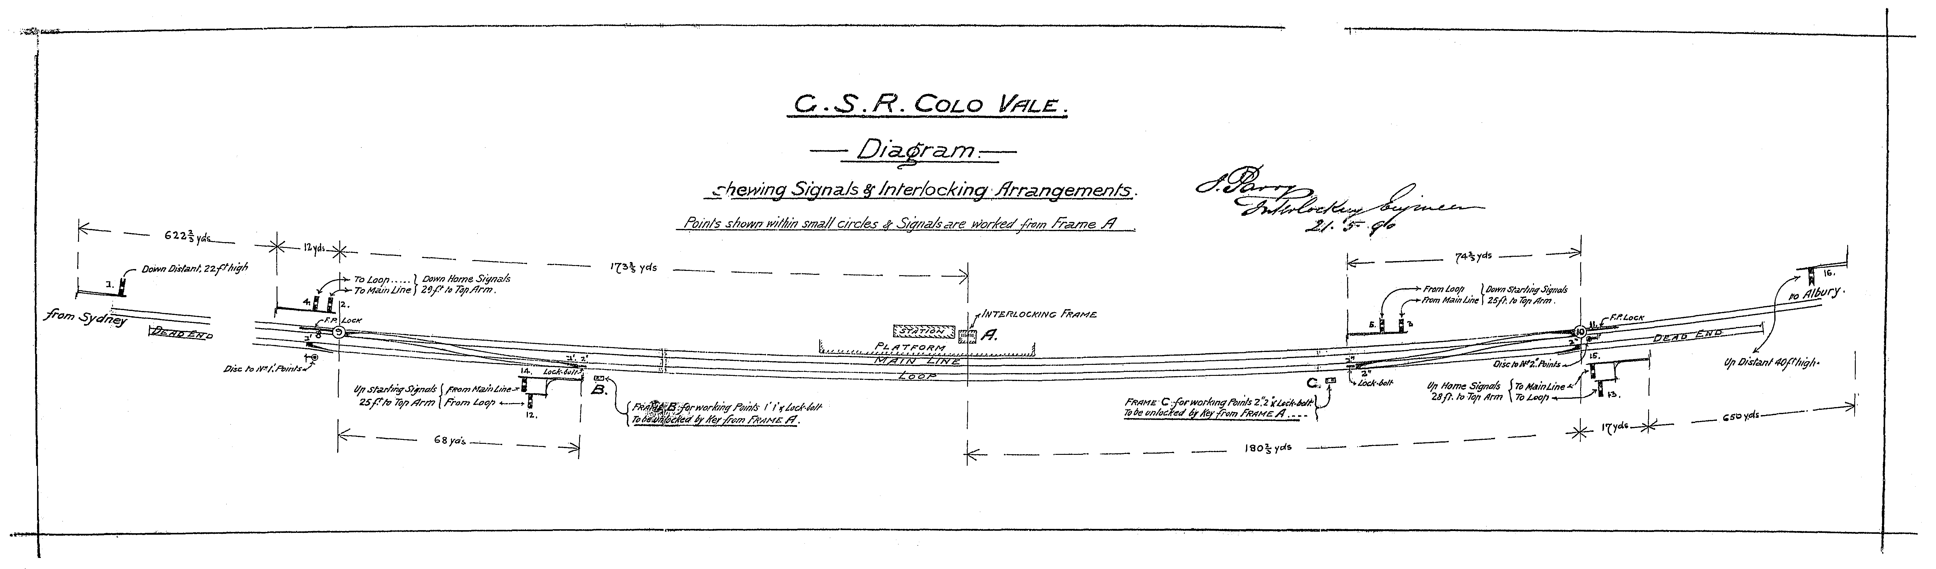
In addition to the loop and the refuge siding, two goods sidings – one a loop and the other a dead end – were provided as was a short loading bank and goods shed siding. Connections to these sidings were operated from adjacent ground frames.
Duplication of the southern line proceeded in fits and starts, with even short sections of double line being commissioned as soon as they were trafficable. The short double line section between Marulan and Arrangull, to the south, was opened on November 26, 1913. To the north of Marulan, double line was opened to Tallong on December 13, 1915. Somewhere in the mix, Marulan got a 24-lever manual interlocking frame.
Once local duplication works were complete, things settled down at Marulan for many years. The basic layout is as shown below.
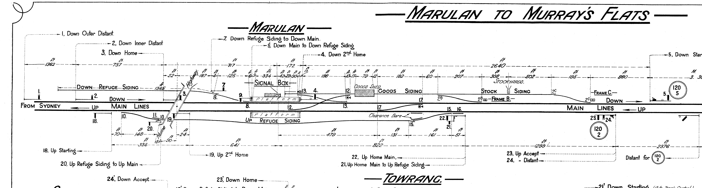

The Marulan facilities are simply described. A pushback Down refuge siding was provided as well as an Up refuge loop. The down siding was little used in recent times and was abolished in the 1970s. The Up loop was more useful as the section ahead was manual block, and the section varied in length depending on which boxes were switched in at any given time. A slow train could head straight into the refuge and sit there happily out of the way until a path ahead was clear.
The apparently complex point work at the Goulburn end of the station was partly due to the location of the goods shed, and while many places on the southern line had their diamond crossings removed or replaced with two tandem crossovers, Marulan’s survived until the final run down of facilities in the early 1980s. By 1989, the only point work left at Marulan was the trailing main lines crossover and a single lead into the goods shed.
Automatic signalling was introduced towards North Goulburn on April 21, 1921, while it was extended to Medway in 1992 at the same time as Marulan box was abolished. Medway had the distinction of being a very rare example of block telegraph being operated from a route set panel box.
By 2005, the Marulan facilities had been enhanced with the provision of an emergency facing crossover and an additional trailing connection to the goods siding, making it theoretically possible for a stone train to run-round. However, by 2013, the arrangements comprised the facing and trailing crossovers and, once again, only a single connection with the siding. This reduction in siding access probably had something to do with the new siding serving Lynwood Quarry, a couple of kilometres to the west.
THE SYDNEY-BOUND PLATFORM
In November and December 1915, the main railway line was duplicated on both sides of Marulan and the existing Sydney-bound platform was erected at that time. Access to the platform used an at-grade pedestrian level crossing using timber planks between the rails. A timber framed and weatherboard clad waiting shed, measuring six feet six inches by ten feet two inches, was constructed on the platform. It had a single pitched roof which sloped towards the rails, with the roof rafters extended three feet to form a narrow awning. This low-cost design was consistent with one of the dominant designs applied to duplication structures elsewhere on the Main South line. Appendix 2 shows the frequency of the use of the cheap, skillion-roofed style, especially on the corridor between Picton and Goulburn. The Appendix also shows the use of a more expensive style with a gabled roof in 1915 which, roughly speaking, was built at more important locations. The same design of small, single-pitched buildings was also applied to many signal boxes, including the one at Marulan, between Picton and Goulburn. One Sydney newspaper described the track duplication as “an expensive undertaking”. Even at Marulan, “heavy earthworks were necessary” and no doubt the use of cheap buildings was one way of minimising expenditure. The amazing aspect is that extensive duplication proceeded during World War One when capital funding was tight. Luckily, the duplication project between Picton and Harden had been approved prior to the start of the War.
The Railway Department was, in the 1960s, keen to trial new materials that provided lower initial and maintenance costs. One new product that came on the market from Besser in the early 1960s was the use of large, hollow concrete blocks. The walls were formed by the blocks and were void of windows. The near-flat roof was formed by a single re-inforced concrete slab. This was the first use of a concrete roof after the construction of platform Nos. 16 to 23 at Central Station in 1926. The Department first used these Besser concrete blocks in 1964 at Waverton on the Sydney-bound platform in a quite unusual design of platform canopy. In 1965, the same product was used at two locations, namely at Marulan and Kembla Grange, where the structure for the latter station was also an unusual design. The last use of the large concrete blocks occurred in 1966 when an extension was made to the control room on the Sydney-bound platform at Thirroul. By the time 1966 arrived, the Department was experimenting with other new building products, especially metal cladding.
A plan was registered on 10th January 1965 for the construction of the present, small waiting shed on the Sydney-bound platform. It measures about 10 feet by 10 feet and contains a fixed seat. The provision of a near-flat roof was a common trend in the 1960s as it provided the lowest possible expenditure. The one outstandingly good advantage, which the Department recognised, was the absence of the need to paint the building. Someone, unnecessarily, painted the structure white in the 1970s to match the building on the opposite platform. Sydney Trains has continued to diminish the heritage values of the structure by applying terracotta coloured paint to match the building on the Goulburn-bound platform. The tragedy occurred about 2016. Notwithstanding the cultural desecration associated with the painting, this simple, concrete building is of heritage significance because of its technological innovation.
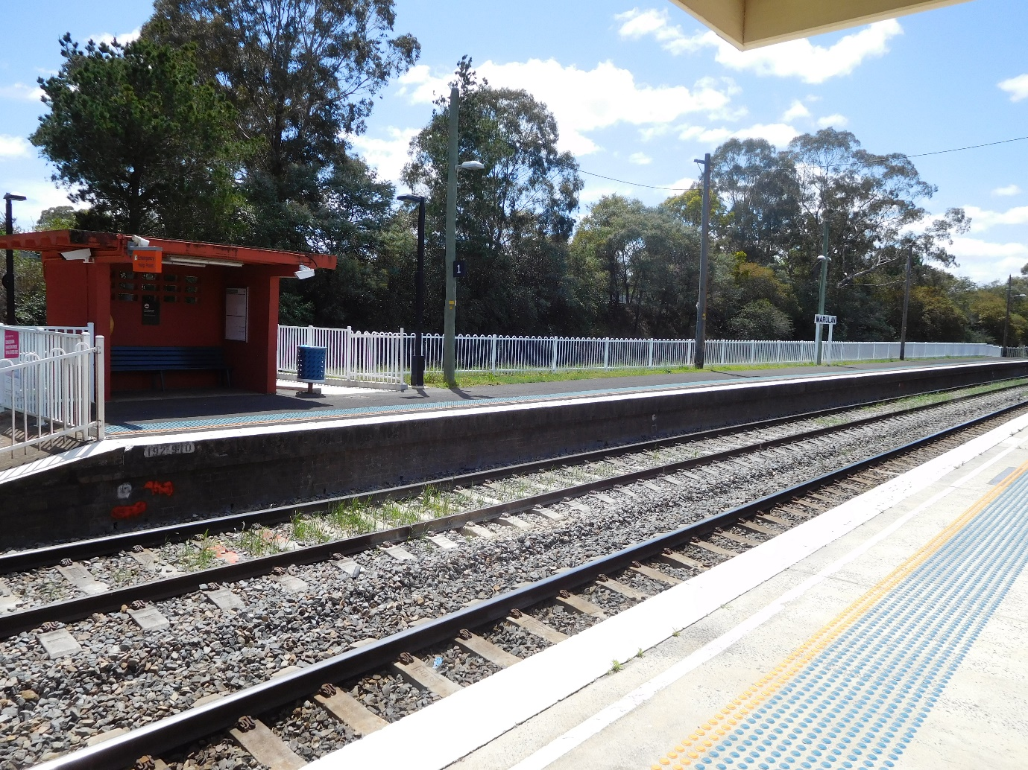
This image shows the waiting shed on the Sydney-bound platform. It was constructed of precast, hollow concrete blocks. The image also identifies the location where the original platform was truncated. The steel fencing at the rear of the platform is the typical CityRail style with the loop top.

Is the date in 1965 for the plan registration important? In a way, yes. On 6th March 1965, the 1915 timber waiting shed on the Sydney-bound platform was burnt down in what was known locally as the Chatsbury bushfire. It is a well-known belief that the concrete block waiting shed was built in response to the destruction of the timber structure in the fire. This does not appear to be the case. The use of the large concrete blocks was part of a wider organisational policy to minimise construction and maintenance costs, as reflected in the date of the plan registration some two months before the fire. Sadly, the plan for the building was never delivered to the Railway Department Plan Room and, thus, is unavailable for inspection to check of the approval date. So, did the idea of providing a concrete waiting shed occur before or after the Chatsbury fire? That’s a mystery for the time being.
While the station was under the control of the Railway Department, the Sydney-bound platform featured attractive hedging at the rear of the platform. With the establishment of the Public Transport Commission from 1972, things changed a bit. At an unknown date in the 1970s, the Sydney-bound platform was shortened from 488 feet (149 metres) to its present length of 413 feet (126 metres) “by dynamiting the full length between the shelter shed and the original (southern) end of the platform”.
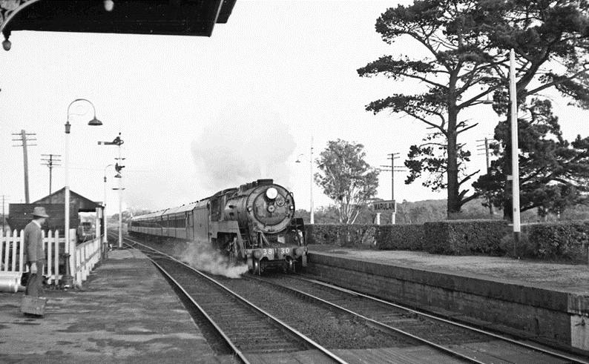
On 22nd August 1992, barrier booms, bells and “don’t walk” signs were installed at the pedestrian level crossing between the two platforms. The former timber planking between the rails was probably replaced at that time, if not earlier.

THE POST OFFICE
The first inkling of a postal facility occurred before the station opening. From 17th September 1867, Hugh Montgomery, a storekeeper at the Marulan railway construction camp was authorised to sell postage stamps.
In 1869, the local post office relocated to the Marulan railway station. According to local historian, Maureen Eddy, post office business was initially conducted in part of the ladies’ waiting room until a small office was built “30 or 40 yards from the platform”. She says that, in 1871, the post office building was moved right up against the station building to facilitate the running of both by Mr Jarvis, the then Station Master. Unfortunately, parts of Maureen’s account are difficult to follow, nor does she cite her sources, but she is very thorough in her work otherwise. There was pressure to remove the post office from the station because of the amount of time staff had to divert from railway business, but the post office remained at the station until 1885. Mr Moodie, the Station Master between 1878 and 1889, at which time he retired at 60 years of age, was too busy to attend to postal matters and his wife and two of his four daughters operated the post and telegraph office until it was relocated from the station.
There is a small addition to the rear of the building on the Goulburn-bound platform which was, according to local oral and written history, used as a post office. In 1884, the word circulated around town that the post office would be moved into another office in the station building. A press article confirmed the existence of vacant space following the departure of the Station Master and his family from the building. The residents wanted a new post office in a more central location – not at the station, out of the way of most people. There is a sandstone step into the structure which is well-worn. That would suggest heavy pedestrian traffic, suggesting use as a post office.

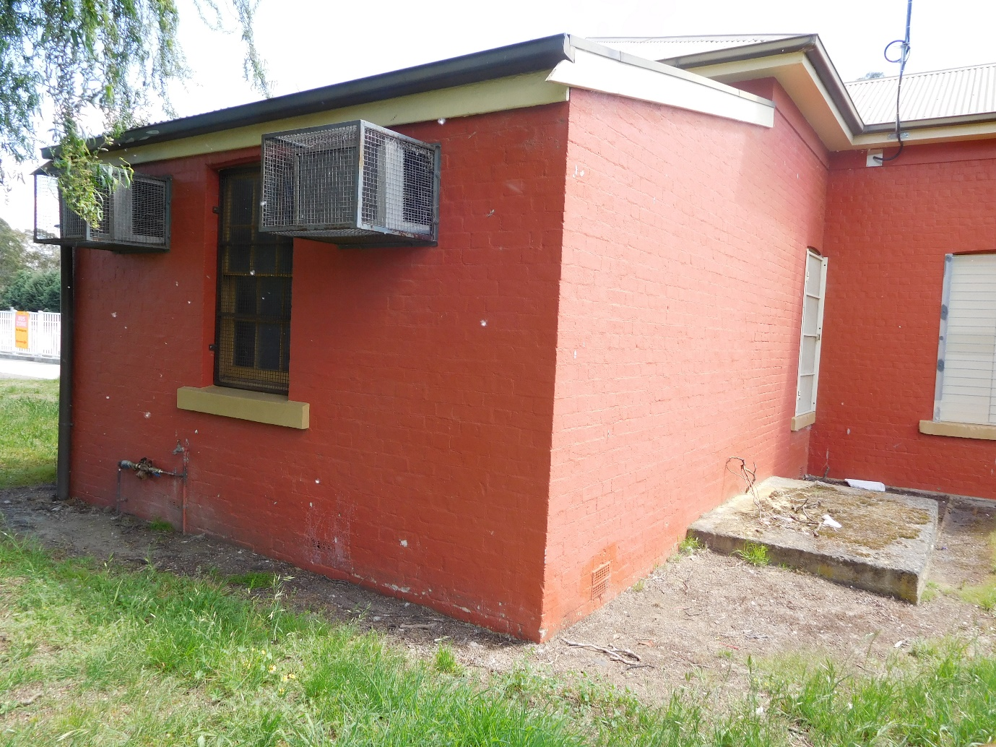
This previous image shows the addition at the rear of the structure which was, according to local historical sources, housed the post office in the 1870s and 1880s. An unusual feature of the structure is the different types of bonding of the brickwork. Another unusual feature for that time. Is the use of a skillion roof.

There is other evidence that casts doubt on the origin and use of the rear addition. Firstly, there was not a single example in the 19th century of a brick building with a single-pitched roof either built by the Railways or built by anyone anywhere. Secondly, the bond of the brickwork varies. Most of the brickwork on the building on the Goulburn-bound platform is set in English bond, though the skillion roofed addition at the rear is formed of an irregular garden bond, meaning that the bond is all over the place. That variation in the bond suggests that the rear addition was constructed locally, without the involvement of Head Office design staff. What exists in 2018 seems to be a building of local origin, with a well-worn step and a skillion roof, for an unknown purpose - another mystery.
As at 31st December 1870, the post office combined the duties “of the electric telegraph or the railway”. A public telegraph office was opened in 1873 at the station.
The local press in November 1883 indicated that “the authorities” had called for tenders for the erection “on the reserve” of one of “Elford's patent portable houses”. This was considered inadequate to the people of Marulan and they, through their local Member of Parliament, John Gannon, protested about the proposed “temporary and insignificant structure”. The Post Master General replied in March 1884 indicating that a permanent brick post office would be built at the station. Tenders for the erection of the temporary post office building were cancelled.
In October 1884, the Railway Department confirmed that a new post office would be built at the railway station. This announcement angered the local residents who insisted that the post office should be more conveniently located at the corner of the Great Southern Road and Station Street (now called Thoroughfare Street). Guess what? The post office was not built on the Marulan station platform, but some distance away on the main road at 68 George Street in approximately the location sought by the local community. That was another case of local political pressure led by the Parliamentary Member for Argyle, William Holborrow, providing results. The post office building survives in 2018.
George Cowdery was the Engineer-in-Chief for Existing lines, a position created (for a second time) in 1876 and occupied by Cowdery since 1878. He approved a brick building for use as a post and telegraph office. It was 31 feet by 12 feet internally and looked like a residence with its gabled roof with chimneys at each end and a small, ornate transverse gable over the entrance. A narrow awning was supported by posts on the front elevation. It consisted of two rooms separated by a central corridor. One room was for postal services and the other for telegraph business, though local historian, Maureen Eddy, states only one room was used as an office and the other as a residence for an unmarried officer. Cowdery approved the plan for the new post office on 24th September 1884 and tenders closed on 14th October 1884 for the erection of the new facility. The contractor was L. Le Breton and another person named Donohue, who signed the plan on 20th May 1885. Le Breton had built the very large Junee refreshment room in 1883 and it opened on 5th March 1885 while he worked on the Marulan post office.
Why would the Railway Department expend money on building a post office structure which were, with this one exception, paid for by the Post Master General’s Department? This is an especially pertinent question considering the new post office was erected about 400 metres from the station on the main drag through town. Oral history suggests that the Railway Department undertook to prepare and pay for the new post office because the facility at the station was involving a considerable amount of time by the Railway staff. On the other hand, it was possible that the Railway Department was re-imbursed for the work. The ‘real’ reason for the Railway Department’s involvement in the provision of the off-premises post office equals another mystery.
The post office was still at the railway station in April 1886. The replacement was forecast to be opened in December 1885 but that did not occur and it opened in August 1886.
THE RAILWAY RESIDENCES
A – THE 1868 COMBINATION STATION/RESIDENCE
Between 1868 and 1883, the Station Master resided in the combination structure on the platform. It is not surprising that John Gannon, one of the local Members of Parliament, in 1882 was surprised by the small size of the residential accommodation. The residence had to accommodate the Station Master, one A. Moodie, his wife, two sons and four daughters and share a single toilet with members of the public using the platform.
B – THE STATION MASTER’S 1882-APPROVED FREE-STANDING RESIDENCE
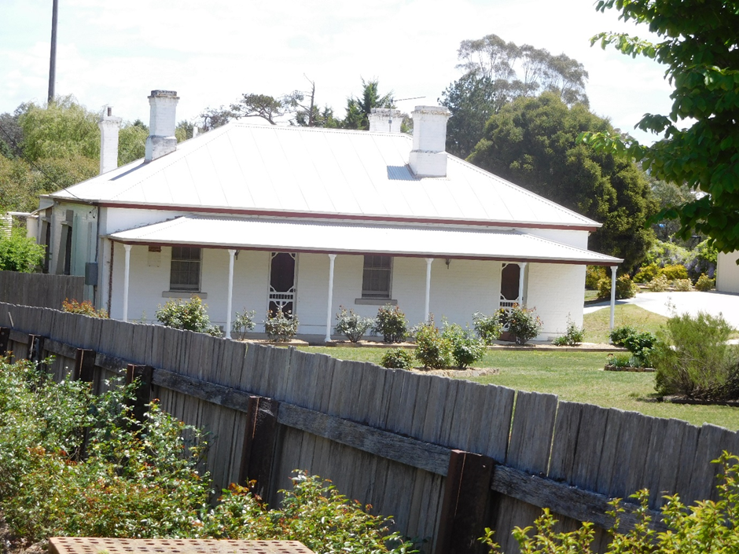
One of the mysteries of Marulan station is the location of the Station Master’s residence. Rather than being positioned in the usual locations such as the station forecourt or within the actual rail corridor, this house is positioned several hundred metres away from the station and, more importantly, faces the main road through the village rather than the railway line.

By the end of 1882, work on a detached residence was under way. For whatever reason, the structure was located away from the station with a frontage to the main thoroughfare through the town. What appears most mysterious is the position of the house on the block of land. Why? The allotment was unusually very large, containing over 43,000 square feet (4,000 square metres) and, at the time of construction, the house was centrally positioned. Some of the original allotment was subsequently sold, making the residence appear lop-sided on the allotment today.
The 1882 residence was of brick construction with a hipped roof and two symmetrically placed chimneys on the side hips of the roof. The style accorded with a design in universal use with the Railway Construction Branch on new lines, but the design was also used, to a lesser degree, by the Existing Lines Branch. The Marulan house was not the only example of that style approved in 1882 on an existing line. The Station Officer’s house at Towrang, the Locomotive Foreman’s house at Wallerawang and the Pumper’s cottage at Kerr’s Creek were of very similar design and all approved in 1882. The Marulan residence is located at 74 George Street. The press reported in 1884 that fencing was being erected around the residence.
Appendix 3 indicates other stations between Picton and Goulburn that received free-standing residences after the official line and station openings and up to 1900. What Appendix 3 shows is a concentration of residences between 1881 and 1883, when the house was substantially altered at an unknown time by expanding the width of the structure on the Medway Junction side and, in so doing, obliterated the original symmetry of the dwelling.
The Station Master’s house remained in State Rail Authority ownership until at least 1990.
C – THE 1890 NIGHT OFFICER’S HOUSE
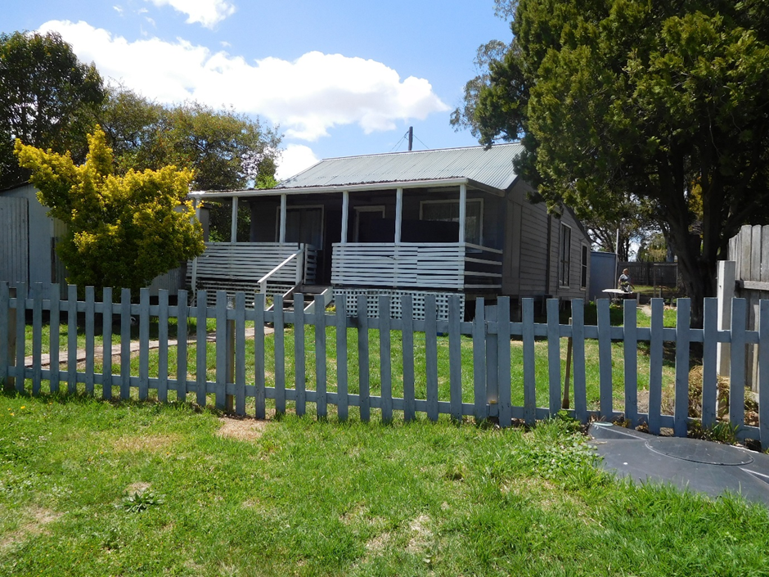
This image of the Night Officer’s residence shows the non-original front verandah. At least this structure faces in the general direction of the railway corridor and addresses the road between the former Hume Highway and the station.
The second residence at Marulan was approved in 1890 for the Night Officer. It was located about half-way between the station and the Station Master’s house. It was a cheaper structure, this lower cost being reflected in the smaller overall size, timber construction and gabled roof. It is located at 1 Thoroughfare Street. Appendix 3 indicates that the Marulan residence was one of seven cottages approved in 1890 and 1891.
In 1895, the press reported that “the railway station master's and night officer's residences were surrounded with pleasant and well-kept gardens”.
The comparative evidence indicates that, both the 1882 and 1890 residences, were approved in response to a broad, departmental programme to increase staff housing rather than specific stimuli restricted to Marulan.
A plan was prepared in 1933 to radically alter the appearance of the residence on the street elevation to provide a new bedroom. A second plan was issued in October 1934 to add one more bedroom to the existing three bedrooms, but this time at the rear of the cottage. A side verandah was also proposed. Those two ideas went nowhere. A further revised, but completely different, scheme was prepared in December of that year omitting the additional bedroom and also deleting the proposed side verandah. Mysteriously, the number of bedrooms was to be reduced from three to two. The deleted bedroom was to become a bathroom – a distinct space that had not existed since construction in 1890. That scheme also went south. Finally, in 1935 the fourth scheme, and the one that went ahead, involved the extension of the rear verandah and the installation of a bathroom at the newly-extended end of the verandah. Now the cottage was back to three bedrooms. Highlights of the 1935 changes were:
- Two new external walls to be covered by rusticated weatherboards to match the remainder of the dwelling,
- Small corrugated iron to line two of the three internal walls,
- Retention of existing single-pitched roof – if possible,
- Re-use of an existing bath from the laundry,
- Drain to be formed by four-inch diameter earthenware pipes,
- Connection of the drainage to the laundry drain, &
- Relocation of two existing rain water tanks.

In 2018, the Night Officer’s house is privately owned. The front verandah has been enclosed using Fibrolite sheeting and the entry steps have been rotated 90 degrees.
Where’s the mystery? Well, Mulwaree Shire Council has renumbered the house in 2018 from 1 Thoroughfare Street to 15 Thoroughfare Street. Why? That’s also a mystery to the present occupants.
OTHER INTERESTING THINGS NEAR THE STATION
There are quite a few engaging features of the area adjacent to the main platform building. These are set out below.
THE DOCK PLATFORM
At the Goulburn end of the Goulburn-bound platform, there is what is known as a dock platform, meaning a section of line behind the main platform which is accessible by the absence of fencing for the transfer of goods between road and rail. While the dock has survived into 2018, the rails within the dock have been removed.
At the time station was opened in 1868, such a dock platform would have been used for the transfer of horse-drawn carriages, which would have been conveyed by passenger train along with the passenger. These dock platforms were placed at either end of the main platforms but there is no consistent pattern to explain why they were located at one particular end. In the case of Marulan, the location of the dock platform at the Goulburn end would have made sense as the station was the terminus for some time and it would have facilitated movement of bodies and carriages. Such logic was not always applied to other stations. The most sensible arrangement at country stations was the location of dock platforms at each end of the main platform and this did occur at a few locations.
The noteworthy physical characteristic of the dock platform is the vertically placed brick walls holding back the earthen formation on each side of the track. This vertical expression contrasts with sloping walls for platforms facing main lines. The use of sloping platform walls terminated with the departure of John Whitton in 1889.
THE SIGNALLING HUT
Immediately behind the building on the Goulburn-bound platform is a small structure containing, or did contain, signalling equipment. The interesting feature of this cubby house is the covering of the exterior walls, which are sheeted with what was known in the language of the New South Wales Railways as “small corrugated iron”. This product was used strictly by the Way and Works Branch for internal use, as was the case in 1935 for the lining of the internal walls of the bathroom in the Night Officer’s house. However, of all sections in the Department of Railways, it was the Electrical Branch which used materials in ways inconsistent with the main stream of Departmental policy. This was evident, for example, on the use of flat Fibrolite sheets for the roofs of sectioning huts and also with the application of terracotta tiles for roofs of traction substations. This little building at Marulan, therefore, demonstrates the mysterious activities of the workings of the Department of Railways.
THE SITE OF THE FORMER TENNIS COURT
A bit further on away from the station, but still behind the station building, was the Railway Institute tennis court. It is marked in 2018 by the grassed area of undeveloped land. Oh! You don’t know about the Railway Institute? It was a branch of the Railway Department that provided educational, cultural social and sporting services to the staff and their families. Tennis clubs and courts, as well as a wide range of other facilities, were provided by the Institute in many country towns. It still exists to carry out recreational activities for transport employees and others.
THE STATION GARDENS
A considerable amount of earth was excavated to extend the Goulburn-bound platform at the Sydney end and, in so doing, created a steep embankment. Over the years, the embankment has been planted with flowers and this floral display lasted until the 1990s, at which time CityRail purged virtually all vegetation from most stations, including Marulan. Gardens at railway stations became departmental policy in 1899, when the Railway Commissioners realised that it was an excellent way to divert attention away from the inadequate funding for the maintenance of station buildings. In that year, the Railway Department commenced annual garden competitions. As well as plantings on the embankment, other vegetation on the platform included potted plants in front of the station building and attractive hedging on the Sydney-bound platform.
THE ACCESS ROAD TO THE STATION
Most towns in New South Wales have either a Station Street or the similar named boulevard. At Marulan, Railway Parade exists but does not connect the passenger station with the main road. Instead, it runs parallel with the railway line south of the station. Road access to the goods shed and goods siding existed from Railway Parade. Mysteriously, the road that connects the station area with the former Hume Highway is called “Thoroughfare Street”. Why is that a mystery? Because there may or may not have been a thoroughfare, with Thoroughfare Street possibly terminating at the station. The road may or may not have been not divided by the railway corridor in 1868.
What is the evidence? The single line level crossing shown on the old parish maps is very close to the station. These maps also show Wollondilly Street, on the up side, leading to this level crossing and continuing on to an unnamed section of road we now know as “Thoroughfare Street”. This was not known as Thoroughfare Street prior to the arrival of the railway. How do we know that? In the 1880s, press articles referred to the road leading to the station as “Station Street”. However, the old parish maps of Mooroowoolen all show Station Street running parallel to the line on its northern side and one block back, and no name for what we now know as “Thoroughfare Street”. What’s going on? How come? Place a tick against the word “mystery”.
THE PARK WITH THE STRANGE NAME
Nowadays, passengers in need of a public toilet while waiting for a train or bus are able to use the very clean facilities in the Tony Onions Memorial Park, which has access from Thoroughfare Street through vacant railway-owned land. The Onions are a well-known family in Goulburn and surrounds. In the 1980s, Tony Onions and his wife were the owners of “Lockyersleigh”, and Mrs Jean Onions (nee Rankin) died only last year. The couple took over the property from her brother. According to local historian, Maureen Eddy, Tony was involved in many organisations in Goulburn and Marulan. He was killed in 1989 and Marulan residents arranged to have the Park renamed in his memory.
There is a railway connection. Ever since 1868, the land which forms the Tony Onions Memorial Park was owned by the Railway Department. The local, inside knowledge reveals that the former Member of Parliament, Ron Brewer, negotiated with the Railways in the 1950s for the sale of part of the Railway land to form a park, later to be named after Mr. Onions.
LYNWOOD QUARRY
The Lynwood quarry siding is on the southern (‘down’ in railway parlance) side of the line and is located so that trains can be loaded either directly from the crushing plant or from adjacent stockpiles. The siding is also equipped with a run-around loop. The main quarry road crosses the Main South line by way of an overbridge and there is also an adjacent bridge carrying a conveyor belt from a primary crusher on the north side of the line to the rest of the crushing plant on the south side of the line.
Lynwood quarry is owned by Holcim and is a new operation. The main quarry is on the northern side of the Main South while the crushing plant is on the south side of the line. The main quarry haul road crosses the railway via a new concrete overbridge, and there is also an adjacent bridge for a conveyor belt. Holcim rail most of their product, but a proportion was planned to go out by truck. Therefore, as part of the consent condition for Lynwood quarry, Holcim was required to fund the new highway interchange at the original site of Marulan so that the trucks could enter and leave the highway safely. Most of the interchange is public road as it also serves the road to Marulan South and the road to Bungonia and makes highway access from these roads much safer.
For the Lynwood trains, the product is loaded directly from the crushing plant or adjacent stockpiles. Train operations for the quarries at Peppertree and Marulan South are as described in Railway Digest in August 2016.
THE 21 MYSTERIES OF MARULAN STATION REVIEWED, SUMMARISED AND ANSWERED
The biggest mystery of the history of Marulan station is the date of the alterations to the 1868 building. Both the when and the why are unknown. This study suggests that the question of altering the building started in 1882 and gathered pace in 1884 when the Commissioner and Engineer in Chief for Existing Lines visited the station and noted the vacant internal spaces. It is a fair bet that formal approval was granted in about 1885 and construction was carried out in 1886.
The study also demonstrates one important feature of railway management in the 1880s. With a bundle of available cash, there was no shortage of official commitment to provide improved station facilities at almost every location on the rail corridor between Picton and Goulburn. The improvement work at Marulan was not so much related to any local increase in population or passenger usage but related to a system-wide policy by the Railway Department to enhance the experience of passengers at stations. This widespread programme of public expenditure is reflected in the extensive examples given in Appendices 1 and 3.
Marulan received a station building in 1868 with a typical example of a brick combination office/residence on the existing Goulburn-bound platform. It also received a typical timber waiting shed on the Sydney-bound platform in 1915. It was the change from the combination structure to a solely railway structure in the 1880s that was atypical.
Even before an analysis of the building begins, a mystery exists that concerns the name of the place after the opening of the post office at the station in 1869. What silly simpleton would call the station, Marulan, and call the post office at the very same location a different name, viz. Mooroowoolen? A land developer, Mr Morrice of “Glenrock”, is said to be the person who selected the name Mooroowoolen. That selection looks to be a variation on the name “Moorooauling” noted by James Meehan in his Surveyor’s Notebook in 1818. Charles Throsby, in his diary of the same time and expedition, spells it “Mooraulin”.
From a lovely Georgian-influenced design in 1868, the Railway Department mutilated the overall design symmetry of the structure to provide an ugly blob of a building. Why the officials did what they did is a mystery. Senior staff in the Railway Department realised the ugliness of what they had done and set about providing two rare decorative features to enhance the presentation of the building. These were the fluted cast iron awning columns with ornate capitals and brackets and the installation of spandrels at the ends of the platform awning.
The mysteries at the station are not restricted to the 1880s platform building conversion process. The erection of a separate residence for the Station Master in 1882 in a location totally distant from the station is another mystery. Not only was the location of the residence a puzzle, the choice of the design was unusual for a station on an existing line. The design was more in keeping with what the Public Works Department was erecting on new lines. What about another mystery? Why did the Railway Department draw up plans in 1885 for a post and telegraph office? To railway people, preparing a plan for a location other than at the railway station does not make sense, but placing it in the main street made sense in the 1880s and makes sense to local residents in 2018.
Let’s also chuck-in the mysteries about the Sydney bound platform. Why was Marulan chosen as one of the very rare examples in 1965 of concrete block construction for the waiting shed? Also, there is a related mystery as to whether the concrete shed was approved prior to or after the Chatsbury fire in March 1965. Also, why did the Department of Railways use explosives to shorten the Sydney-bound platform and why was it necessary to shorten the facility? In more recent times, CityRail grossly reduced the heritage values of the 1868 building by the removal of four chimneys and the removal of the remnant slate roof, not to mention burying the bases of the awning columns. Why so and why was there no consideration given to the heritage management of the building? That is a big mystery in these enlightened times.
There are more unknown aspects than known occurrences relating to the history of Marulan station. The table below summarises the 21 unknown/unexplained occurrences which aggregate to form the mysteries of the place.
TABLE: A SUMMARY OF THE 21 MYSTERIES RELATING TO MARULAN RAILWAY STATION
NO. OF THE MYSTERY | YEAR | WHAT’S THE MYSTERY? | WHAT’S THE ANSWER?
1 | 1867 | Why was the layout of the approved plan partly reversed? | Second thoughts by the staff
2 | 1867 | How come Marulan is the only known instance where approval of the plan and advertisement of the tenders occurred on the same date? | It has the smell of urgency at best and corruption at worst
3 | 1869 | Why was one name, Marulan, chosen for the station and another, Mooroowoolen, chosen for the adjacent post office? | The name, Marulan, was in use at the first village site
4 | 1882 | Why was the stand-alone residence for the Station Master erected so far from the platform? | Part of the side fence of the station, which is covered in wisteria, is part of the boundary fence of the former Station Master’s house block. Compared to other locations, such as Mittagong in 1874, the distance between station and residence was not too great.
5 | 1882 |  | The original allotment was much larger than it is today. It included the block now occupied by the former Night Officer’s residence and the park.
6 | 1883 | Why were 30,000 bricks delivered to Marulan station? | The construction of the Station Master’s house and the extension of the station building would collectively account for many of the 30,000 bricks. Perhaps the brick facings of the dock platform (shown on the 1888 track plan) were also constructed at this time, and not in 1868?
7 | 1885 | Why did the Railway Department prepare plans for and construct the off-premises post office? | Unknown
8 | C1883-85 | When and why was the 1868 platform building expanded? | Unknown
9 | C1883-85 | Why were the ornate iron columns and spandrels provided? | Unknown
10 | 1868-1885 | What was the correct height of the original platform – 2 feet, 2 feet 3 inches or the planned 2 feet 9 inches? | It varied over time with additional ballast placed on the track
11 | - | Was the brick addition at the rear of the main building with the skillion roof a post office or something else? | Unknown
12 | - | When was the Goulburn-bound platform extended at the Sydney end? | Unknown
13 | 1933-35 | Why did it take four attempts to provide a bathroom in the Night Officer’s house? | Funding limitations explains part of the complexity
14 | - | Why was the road leading to the station named Thoroughfare Street when it was not a through road? | Thoroughfare Street and Wollondilly Street, via the level crossing over the former single line, comprised the original route of the road to the location of Brayton. Perhaps it really was a thoroughfare at one time.
155 | 1965 | Did the concrete waiting shed pre or post-date the Chatsbury fire? | Available photographs and newspaper reports suggest construction post-dated the fire, but its authorisation pre-dated the fire, so perhaps the fire merely hastened the process of replacement?
16 | 1970s & 2016 | Why was the concrete waiting shed painted and repainted? | Probably for the same reason that the fronts of the “V” set EMUs kept getting repainted.
17 | 1970s | Was Heritage Office approval obtained for the removal of the chimneys and the burying of the awning columns? | A question for the owner to answer
18 | 1970s | Why was the Sydney-bound platform shortened and why were explosives used to carry out the task? | Lowest cost, possibly
19 | - | Who erected the diagonally-set privacy screen in front of the entrance to the former male toilet and when did it occur? | No one from Head Office
20 | 2018 | Why did Mulwaree Council renumber the former Night Officer’s house from 1 to 15 Thoroughfare Street? | Bureaucracy at its best
21 | 2018 | Who stole one of the platform seats in October? | One for the Police

The very substantial help of Paul Daly and Graham Harper is most gratefully acknowledged.

Janet and Dugald Black and Stuart Sharp, 20th November 2018; revised 9th December 2018; further revised 23rd December 2018
APPENDIX 1
TABLE: REPLACEMENT/ENLARGEMENT OF PLATFORM BUILDINGS PICTON (INCLUSIVE) TO GOULBURN (EXCLUSIVE) 1868-1890
STATION & OPENING DATE | TYPE OF BUILDING AT OPENING | DATE OF BUILDING REDEVELOPMENT | NATURE OF REDEVELOPMENT
Picton  01/07/1863 | Six room brick building of Georgian influence with slate, hipped roof | 1881  1882  1884 | “House” over footwarmer shed  New store room & office removed from Bundanoon.  Old store room & hall converted into a waiting room + new turnstile
Redbank  01/08/1885  (in 1886 to Thirlmere) | George Cowdery designed 3rd class timber building with four rooms, posted verandah including attached male toilet | Nil | Nil
Picton Lakes  06/09/1869 (in 1929 to Couridjah) | One room timber waiting shed of unknown description | 1883  1890 | New toilet  Ticket office
Buxton  04/11/1893 | One room timber waiting shed with a skillion roof sloping to the rear (Probably, this structure was relocated from another station) | Unknown | Timber ticket office and an extension to the 1893 building
Balmoral  05/04/1878 | Nil  Platform erected 1881 | 1881  Unknown date | Timber waiting shed with a gabled roof & no platform awning  Second gable roofed structure, with awning
Hill Top  05/04/1878 | One room timber waiting shed with a skillion roof sloping to the rear | 1885 | Timber office 12 feet by 12 feet with gabled roof and platform awning – a mini version of George Cowdery’s third class building
Colo Vale  01/05/1883 | George Cowdery designed 3rd class timber building with four rooms, posted verandah including attached male toilet | 1883  1884 | Nameboard erected.  Turnstile erected at rear of station
Rush’s  01/03/1867  (to Braemar in 1892) | One room timber waiting shed with a skillion roof sloping to the rear | 1881 | Steps at end of platform
Mittagong  01/03/1867 | Six room brick building of Georgian influence with slate, hipped roof | 1873  1881  1882  1883  1886  1887 | Refreshment room opened  Water closet provided  “large parcels office erected”  “Cess pits drained into creek” + flagging laid in front of parcels office.  New water closets costing £107/3/2  Additions to station building (unknown description) £458/4/7
Bowral  02/12/1867 |  | 1882  1889 | New cess pit  New large, brick building
Burradoo  1870 |  | 1879  1891 new site | New waiting shed  New three-room timber building with skillion roof sloping to rails
Sutton Forest  02/12/1867 (in 1877 to Moss Vale) | Six room brick building of Georgian influence with slate, hipped roof | 1881  1889  1890 | Wicket gate erected  Provision of entrance and waiting room for Colonial Governor  Refreshment room & electric lighting installed
Meryla (to Werai in 1901)  19/08/1883 | Waiting shed of unknown description | 1897 track regrading and deviation | Platform buildings relocated to new site
Badgery’s Siding  1878  (in 1890 to Exeter) | No platform until 1888
Jordans Crossing  06/08/1868  (in 1881 to Bundanoon) | One room timber waiting shed with a skillion roof sloping to the rear | 1881  1881  1883 | construction of a George Cowdery designed 3rd class timber building with four rooms, posted verandah including attached male toilet.  Stove in (existing) staff and ticket office.  Two turnstiles erected
Wollondilly  01/05/1885 (to Kareela in 1891) | One room, timber ticket office with gabled roof | Nil  closed 15/03/1916, three months after duplication | Nil
Cable’s Siding  01/06/1871  (in 1897 to Penrose – 1st site) | One room timber waiting shed with skillion roof sloping to the rear + a small timber shed with gabled roof | Nil  closed 15/03/1916, three months after duplication | Nil
Wingello  1882 | George Cowdery designed 3rd class timber building with four rooms, posted verandah including attached male toilet | 1883 | Station buildings erected
Barbers Creek  (in 1905 to Tallong)  16/04/  1878 | One room timber waiting shed with a skillion roof sloping to the rear | 1889/1890 for the ladies’ waiting room and toilet  Date unknown for office | Construction of two detached small, timber buildings with gabled roofs.
Marulan  06/08/1868 |  | 1874  1876  1879  1880  1881  1882  1883  1885 | “Verandah added”  New kitchen  Entrance gate removed  Windows fixed in verandah of SM’s house  Turnstile & nameboard erected  New SM house “in hand”  Platform widened  New post office & fittings in post & telegraph office
Towrang (first site) 09/05/1869 [in 1870 to Carrick] | One room timber waiting shed with a skillion roof sloping to the rear | New site with duplication 23/01/1914 | 1869 building probably remained in situ
Manna Fields  27/07/1869  (in 1874 to Towrang [2nd site]) | Unknown | 1880  1881  1883 | New telegraph office  Timber building relocated from Harden + toilets. Subsequently altered  Urinals drained
Murray’s Flats  03/10/1888 | No building at time of platform construction | Nil | Nil
North Goulburn  1882 | Timber waiting shed and office of unknown description | 1882 | New waiting shed & office

APPENDIX 2
BUILDINGS ERECTED ON DUPLICATION OF TRUNK SINGLE LINES 1890-1920
YEAR OF LINE DUPLICATION | LOCATION | BUILDING MATERIAL | ROOF DESIGN | SIZE & WHETHER THE STRUCTURE MATCHES OR DOES NOT MATCH THE OPPOSITE PLATFORM BUILDING
1890 | Loftus | Timber | Skillion roof | One room 15’ x 12’ – non matching
1890 | Engadine | Timber | Skillion roof, pitched away from track | One room – non matching
1890 | Heathcote | Timber | Skillon roof | One room – non matching
1890 | Waterfall
1891 | Glenfield | Timber | Skillon roof | One room – non matching
1891 | Menangle | Timber | Skillion roof, pitched away from track | One room – non matching
1891 | Lithgow | Timber | Gabled roof without awning | One room – non matching
1891 | Bowenfels | Timber | Curved roof | One room – non matching
1891 | Cockle Creek | Timber | Gabled roof | Three rooms – standard roadside design – non matching
1891 | Adamstown | Timber | Extended roof rafters | One room – non matching
1892 | Macquarie Fields | Timber | Skillion roof | One or two room/s – original building awningless gabled roof
1892 | Minto | Timber | Skillion roof | One room – original building design unknown
1892 | Leumeah | Timber | Skillion roof | One room - original building design unknown
1892 | Campbelltown | Brick | Gabled roof | Three rooms – standard roadside design – non matching
1892 | Douglas Park | Timber | Skillion roof | One room -matching
1892 | Picton | Timber | Gabled roof | two rooms 21’ x 12’ – non matching
1902 | Glenbrook  New site | Brick | Gabled roof | New 75’ long building on an island platform
1902 | Springwood | Brick | Complex roofscape | Existing building converted for use on an island platform
1902 | Linden | Brick | Gabled roof | New 75’ long building on an island platform
1902 | Woodford | Brick | Gabled roof | New 75’ long building on an island platform
1902 | Lawson | Brick | Gabled roof | New 75’ long building on an island platform
1902 | Wentworth Falls | Brick | Gabled roof | Existing building converted for use on an island platform
1902 | Medlow Bath | Brick | Gabled roof | New building on island platform
1902 | Blackheath | NA | NA | Conversion of existing building into island platforms tructure
1907 | Emu Plains | timber | Timber, skillion roof | 16’ x 12’ – non matching
1908 | Mount Ku-ring-gai | Brick | Gabled roof | New building on island platform
1909 | Cowan | timber | Timber, skillion roof | 16’ x 12’ - matching
1909 | Hawkesbury River | Brick | Gabled roof | New building on island platform
1910 | Woy Woy | Brick | Gabled roof | New building on island platform
1910 | Morisset | Timber | Skillion roof | One room – non matching
1910 | Dora Creek | Timber | Gabled roof | Three rooms- non-matching
1910 | Awaba | Timber | Skillion roof | One room – non matching
1910 | Fassifern | Timber | Skillion roof | One room - Non matching
1910 | Teralba | Timber | Gabled roof with rafters extended for awning | Two rooms – non matching
1910 | Mount Victoria | Brick | Gabled roof | Large RRR building
1910 | Hartley Vale | NA | NA | Existing timber building converted into an island platform structure
1910 | Zig Zag | No building | NA | Work starts in April 1908 to replace Zig Zag
1911 | Bell | Brick | Gabled | New building on island platform
1911 | Newness Junction  New site | Timber | Skillion roof | Two rooms – both platform buildings of the same design
1911 | Niagara Park | Timber | Gabled roof with extended rafters forming the awnings | Island platform – design of previous building unknown
1911 | Ourimbah | Brick | Gabled roof | 60’ long – non-matching 9timber building on opposite platform
1911 | Wyee | Timber | Gabled roof | New building on an island platform
1912 | Wyong | Brick | Gabled roof | New buildings on both platforms - matching
1912 | Yarra | Timber | Gabled roof | Design of original building unknown
1912 | Breadalbane | Timber | Gabled roof, narrow awning style | One room – non matching
1912 | Harden | NA | NA | Existing brick building converted into an island platform structure
1913 | Bundanoon | Timber | Gabled | One room – opposite platform altered to match duplication structure
1913 | Towrang | Timber | Skillion roof | New buildings on both platforms - matching
1913 | Cullerin | Timber | Skillion roof | One room – design of building on opposite platform unknown
1913 | Goondah | Timber | Skillion roof | One room – non matching – relocated from Greta
1913 | Bowning | Timber | Gabled roof | Two rooms 25’ x 12’ – non matching
1914 | Carrick | Unknown | Unknown | NA
1914 | Goulburn | Brick | Gabled roof | 120’ brick building – non matching
1914 | Fish River | Timber | Skillion roof | One room 15’ x 12’ – non matching building
1914 | Oolong | Timber | Skillion roof | One room 15’ x 10’ internal – design of original building unknown on other platform
1914 | Jerrawa | Timber | Gabled roof | Existing building converted for use on island platform
1914 | Coolalie  New site | Timber | Gabled roof | One room - new, matching buildings erected
1914 | Werai | Timber | Skillion roof | One room – unknown design of building on opposite platform but was called “waiting shed”
1914 | Yass Junction | Brick | Gabled roof | Large RRR – non matching
1914 | Farley | Timber | Skillion roof | One room – non matching
1914 | Greta | Brick | Gabled roof | One room 15’ x 12’ – non matching
1914 | Lochinvar | Brick – one room | Gabled roof | Matching buildings on both platforms – one four rooms 83’ long – the other one room 15’ long
1914 | Allandale – new site | Timber | Gable roof | One room - matches new building on opposite platform
1914 | Lilyvale | Timber  15’ x 10’ | Skillion roof | One room – no building on opposite side platform relocated to up platform from the old site on the single line
1915 | Branxton | Brick | Gabled roof | Three rooms – non matching
1915 | Helensburgh | Brick | Gabled roof | New building on an island platform
1915 | Otford | Timber | Gabled roof | One room – non matching
1915 | Coal cliff | Unknown | Unknown | NA
1915 | Scarborough | Brick | Gabled roof | New, matching buildings on both side platforms
1915 | Coledale | Brick | Gabled roof | New building on an island platform
1915 | Austinmer | Timber | Gabled roof | New, matching buildings on both platforms, one relocated from Clifton
1915 | Thirroul | Timber | Gabled roof | Three rooms – non matching – building relocated from Scarborough
1915 | Exeter | Timber | Skillion roof | One room 16’ x 12’ - matching
1915 | Wingello | Timber | Gabled roof | WR and out of Room
1915 | Tallong | Timber | Skillion roof | One room – non matching
1915 | Marulan | Timber | Skillion roof | One room – non-matching
1915 | Gunning | Timber | Gable roof | One room – non matching
1915 | Illalong Creek  New site | Timber | Gabled roof | Matching one room structures on both platforms
1915 | Binalong  New site | brick | Gabled roof | New building on an island platform
1915 | Galong  new site | brick | Gabled roof | One room - Matches opposite platform building
1915 | Cunningar | Timber | Gabled roof | New island platform – 60’ long
1915 | Nubba | Timber | Gabled roof | Existing structure converted into use on island platform
1915 | Wallendbeen  New site | Timber | Gabled roof | Matching four room buildings on each platform
1915 | Wallerawang | Timber | Gabled roof | Two rooms 20’ x 12’ – non matching
1915 | Rydal | Timber | Skillion roof | Unknown
1916 | Tarana | Timber | Gabled roof | One room 21’ x 12’ – non matching
1916 | Gemalla | Timber | Skillion roof | One room – non matching
1916 | Spring Hill | Timber | Skillion roof | Two rooms 30’ x 12’ – non matching
1916 | Rocky Ponds  New site | Timber | Skillion roof | One room – matching buildings on both platforms
1916 | Corrimal | Timber | Gabled roof | Three rooms – 54’ long – non matching
1917 | Bulli | Brick | Gabled roof | Four rooms – non matching
1918 | Murrumburrah | Timber | Gabled roof | Three rooms – non matching
1919 | Mittagong | Timber | Skillion roof | Two rooms – non matching
1919 | Bowral | Brick | Gabled roof | Four rooms – non matching
1919 | Stanwell Park | Timber | Gabled roof | New, matching buildings on both side platforms

APPENDIX 3
TABLE: OFFICIAL RESIDENCES BUILT AFTER LINE OPENINGS PICTON-GOULBURN 1860-1900
YEAR APPROVED | LOCATION | WALL MATERIAL | DESIGN | NOTES
1869 | Moss Vale | Brick | Gothic | On hill near station
1870 | Goulburn | Brick | Neo-Gothic, two storey with gabled roof | Located on side of station forecourt
1874 | Mittagong | Brick | Neo-Gothic, two storey with gabled roof | Located at level crossing 400 metres from station
1877 | Picton | Brick | Georgian, two-storey with hipped roof | Located on side of station forecourt
1878 | Tallong | Timber | Single storey with hipped roof | Between station and dam wall – originally Pumper’s residence
1881 | Balmoral | Timber | Carpenter’s Gothic, single-storey with gabled roof | Adjacent to line
1882 | Wingello | Timber | Design unknown | Relocated from Bowning
1882 | Towrang | Timber | Single storey with hipped roof | On hill 200 metres from station
1883 | Marulan | Brick | Georgian, single storey with hipped roof | 300 metres from station
1883 | Colo Vale | Timber | Carpenter’s Gothic, single-storey with gabled roof | Adjacent to line
1890 | Bundanoon and Wingello | Timber | Carpenter’s Gothic, single-storey with gabled roof | Adjacent to line
1890 | Exeter – two cottages | Timber | Carpenter’s Gothic, single-storey with gabled roof | Adjacent to line
1890 | Bowral | Brick | Carpenter’s Gothic, single-storey with gabled roof | Across the road from platform – design would become standard J 4 design
1890 | Marulan and Hill Top | Timber | Carpenter’s Gothic, single-storey with gabled roof | Marulan structure located 150 metres from station on road leading to platform
1890 | Thirlmere | Brick | Carpenter’s Gothic, single-storey with gabled roof | Adjacent to level crossing
1891 | Couridjah & Hill Top | Timber | Carpenter’s Gothic, single-storey with gabled roof | Adjacent to line
1897 | Werai | Timber | Carpenter’s Gothic, single-storey with gabled roof | Adjacent to line

New South Wales Government Gazette, 18th March 1835, No.159, p. 148.
The name of the original village at the intersection of the Great Southern Road and the Bungonia road was Marulan. Parish maps continued to show this village until at least as late as the 1953 edition, which was not cancelled until 1974.
Goulburn Herald, 18th October 1895, p. 3.
A Government Gazette notice of 13th December 1872 names trustees for this church appointed at the date of the notice.
Goulburn Evening Penny Post, 29th July 1891, p. 3. Moodie’s eldest son was the driver of the train involved in the 1885 Salt Clay Creek rail disaster.
M. Eddy, Marulan – A Unique Heritage, privately published, 1985, pp. 42-96.
Ibid., p. 24.
The last combination structure was of two storeys at Emu Plains in 1884.
A Neo-Gothic design was also used for some gatehouses, with surviving examples at Werai and Picton. The same Neo-Gothic design was also, strangely, used for the 1869 Station Master’s house at Moss Vale and Goulburn in 1870. Why? Well, that is yet another mystery.
New South Wales Government Gazette, 3rd December 1867, No.218, p. 3225.
Goulburn Herald and Chronicle, 11th January 1868, p. 5.
New South Wales Government Gazette, 18th August 1871, No.209, p. 1825.
Southern Argus, 25th March 1884, p. 2.
An 1888 plan shows the platform to be 242 feet.
New South Wales Government Gazette, 28th March 1883, No.119, p. 1632.
New South Wales Government Gazette, 27th February 1883, No.74, p. 1078.
This date was based on information from by Maureen Eddy, a local historian. She dated the photograph from her knowledge of the construction of the Anglican Church and Methodist Churches and other information visible in the image.
C. C. Singleton, "The Centenary of the Opening of the Southern Line to Goulburn", Bulletin, May 1969, p. 114.
Goulburn Herald, 24th January 1882, p. 2.
Goulburn Evening Penny Post, 24th January 1882, p. 4.
Ibid.
Goulburn Herald, 15th March 1884, p. 5.
Bowral Free Press, 29 March 1884, p. 2.
Goulburn Herald, 20th June 1885, p. 4.
J. Craddock, Letter to the Editor, Australian Railway History, September 2013, p. 30.
Goulburn Evening Penny Post, 21st August 1886, p. 6.
Goulburn Evening Penny Post, 21st August 1886, p. 6.
Goulburn Herald, 17th April 1886, p. 6.
Goulburn Herald, 13th April 1882, p. 2.
Goulburn Herald, 12th February 1884, p. 2.
Goulburn Evening Penny Post, 6th February 1886, p. 6.
That action to convert an existing room was contrary to the advice of the Post Master General in March 1884 that a new brick building would be erected at the station.
Goulburn Herald, 18th October 1895, p. 3.
Goulburn Evening Penny Post, 31st March 1888, p. 6.
R.T.T. Taaffe, The Use and Selection of Materials in Railway Signal Box Construction 1912-1990, unpublished Ph. D. thesis, the University of Sydney, 1990. pp. 76-81.
“Up” means in the direction of Sydney and “Down” means in the direction of Goulburn.
The Sun, 16th April 1914, p. 6.
Albury Banner and Wodonga Express, 8th August 1913, p. 33.
J. and D. Black, Moss Vale to Marulan: 150th Anniversary of Opening of Railway – Historical Notes: Marulan and Medway Junction, Marulan and District Historical Society, 2018, pp. 13 & 14.
Ibid, p. 14
Ibid., p. 16.
New South Wales Government Gazette, 4th October 1867, No.172, p. 2457.
Goulburn Evening Penny Post, 9th July 1881, p. 7.
Southern Argus, 19th July 1884, p. 2.
Sydney Morning Herald, 19th June 1871, p. 2.
Sydney Morning Herald, 24th September 1873, p. 7.
Goulburn Herald, 29th November 1883, p. 2.
Goulburn Evening Penny Post, 18th March 1884, p. 3.
Goulburn Herald, 11th October 1884, p. 3.
Eddy, op. cit., p. 40.
New South Wales Government Gazette, 3rd October 1884, No.504, p. 6645.
Goulburn Herald, 14th March 1885, p. 4.
Wagga Wagga Advertiser, 7th March 1885, p. 2.
Goulburn Herald, 17th April 1886, p. 6.
Goulburn Evening Penny Post, 24th December 1885, p. 6 and 21st August 1886, p. 6.
Goulburn Evening Penny Post, 29th July 1891, p. 3.
There were possibly other examples of the same design in 1882, including the residence at Wingello. Several designs were in use in 1882 for existing lines.
Goulburn Herald, 12th February 1884, p. 2.
Goulburn Herald, 18th October 1895, p. 3.
According to the SBS television programme, “Who Do You Think You Are”, the actress, Jacki Weaver, is a descendant of another member of the Onions family. Apparently, the silver used in the spade that was used to turn the first sod of the Great Southern Railway in 1850 was mined at “Lockyersleigh”.

